Contact: Jim Rockwell FOR IMMEDIATE RELEASE
RBI Music
Tel: 201-247-7224
Email: jim.rockwell@rbimusic.com

Toca Unveils New Timbale Stands: Enhanced Design Focuses on Player Comfort and Durability
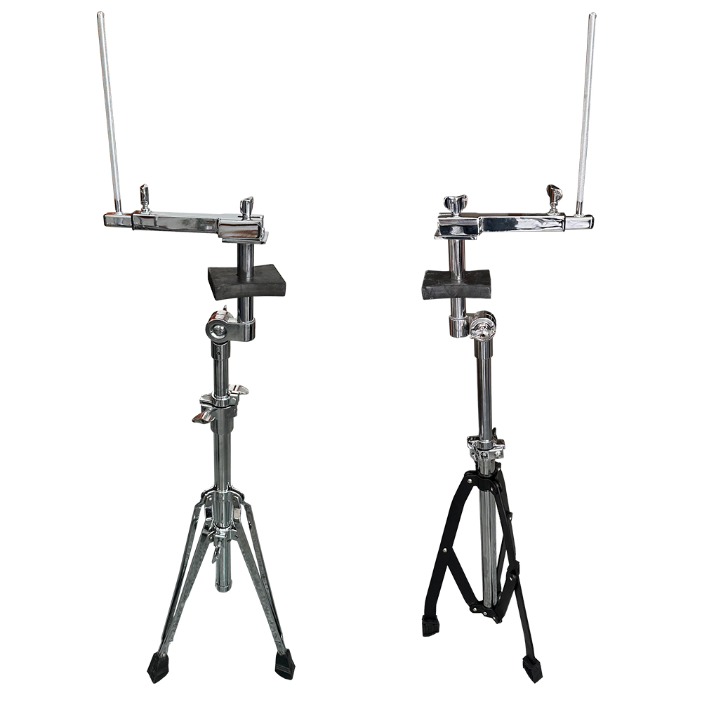
Toca today announced the launch of two new models of professional-grade Timbale stands: the Toca Timbale Stand and the Toca Pro Timbale Stand. These new stands feature heavy-duty construction and a significant, player-focused enhancement to the cowbell mounting system, ensuring maximum stability and ergonomic convenience for percussionists.

The core innovation across both models is an enhanced cowbell mounting bracket. The bracket’s position has been elevated between the drums, a subtle but critical modification that dramatically improves the player's experience.

“Our design team focused on streamlining the locking process for the cowbell bracket,” said Jim Rockwell, head of Toca Product Development. “By elevating the mounting point, we minimize the risk of incidental finger and knuckle discomfort often associated with tightening the securing nut in confined spaces. This simple change allows drummers to focus entirely on their performance, not on awkward adjustments.”

tocapercussion.com
rbimusic.com

