Contact: Jim Rockwell FOR IMMEDIATE RELEASE
RBI Music
Tel: 201-247-7224
Email: marketing@rbimusic.com

Toca Teams with Godsmack’s Sully Erna for New "Black Mamba" Signature Djembes

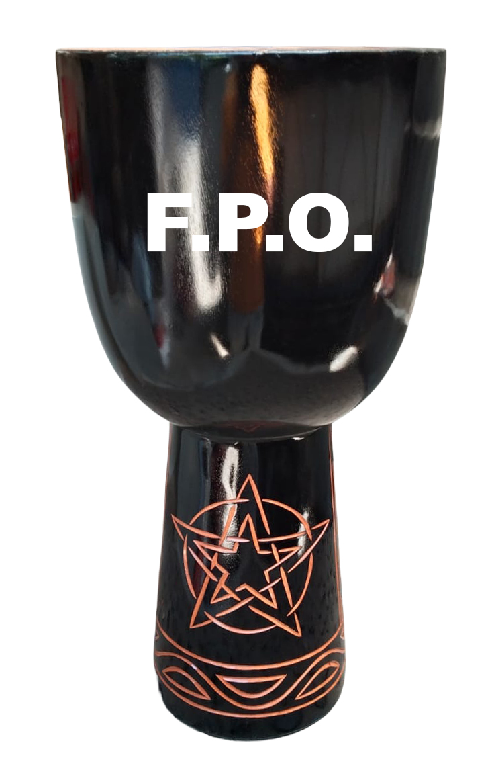
Toca Percussion is thrilled to announce the release of the new Sully Erna Black Mamba Series. Available in both traditional Wood and modern Freestyle versions, both of which are Rope Tuned, these instruments mark the return of a legendary collaboration with Sully Erna, the multi-talented founder and frontman of Godsmack.

Paying tribute to the original Black Mamba drums that Erna helped design, this new series retains the iconic background art that fans recognize while introducing bold new aesthetic elements. The focal point on the base of every drum is the distinct Godsmack "Star" logo. To complete the look, each drum is fitted with a fully black-dyed goatskin head, emblazoned with Sully Erna’s personal logo and signature in contrasting white ink. This creates a visual statement as powerful as the sound these drums produce.

For the purist who demands traditional warmth and eco-conscious construction, the Black Mamba Wood Djembe stands as a masterpiece of sustainability. Each drum is hand-carved from a single piece of plantation-grown mahogany. The shells undergo a rigorous process, being kiln-dried and painstakingly treated with 20 coats of teak oil to preserve the wood and enhance the instrument's longevity. Topped with hand-selected goatskin heads and authentic rope tuning, these djembes deliver a resonant, warm tone. They are available in 8-inch, 10-inch, and 12-inch head sizes.

Built for the rigors of the road and the demands of the studio, the Freestyle version offers Toca’s cutting-edge durability without sacrificing tone. Featuring a seamless synthetic shell, these drums are lightweight and weather-resistant, making them ideal for stage use and drum circles. They are equipped with low-stretch Alpine rope with braided cores to ensure stable tuning, rich bass tones, and piercingly sharp rim shots. For added stability during energetic performances, a non-slip rubber bottom keeps the drum secure. These models are available in 10-inch, 12-inch, and 14-inch head sizes.

"The Black Mamba series represents the perfect blend of Sully Erna's artistic vision and Toca's commitment to quality," said Jim Rockwell, Head of Product Development at Toca Percussion. "Whether a player chooses the traditional warmth of the mahogany model or the projection and durability of the Freestyle, they are getting a drum that embodies the spirit of rock and the soul of traditional African drumming."

tocapercussion.com

