Contact: Jim Rockwell FOR IMMEDIATE RELEASE
RBI Music
Tel: 201-247-7224
Email: jim.rockwell@rbimusic.com

TOCA Drives Creativity with New Elite Pro Congas and Bongos Based on Southern California Car Culture
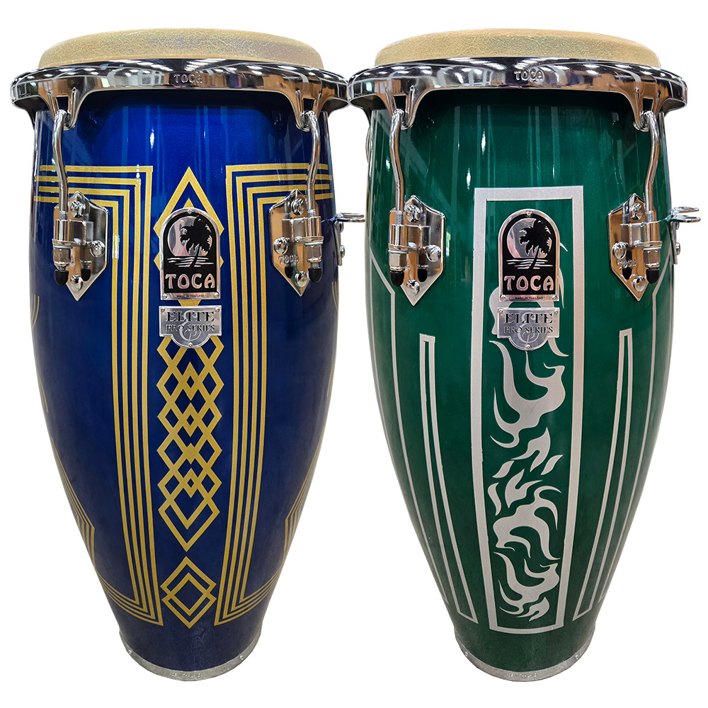
Toca Percussion Toca Percussion, a pioneer in authentic world percussion, is thrilled to announce the launch of the newly redesigned Elite Pro Congas and Bongos, featuring striking finishes inspired by the golden age of Southern California racing and classic 1970s car modification culture. The refreshed series combines professional-grade size and sound with a uniquely bold aesthetic, all while maintaining an accessible price point for the dedicated, intermediate player.

The new Elite Pro Congas and Bongos are unveiled in two high-luster colors: Blue Impala and Eldorado Green. The design is a direct nod to the iconic pinstriping, graphics, and deep metallic paints found on classic cruisers and modded muscle cars of the era, giving the drums a truly distinctive visual presence.

The Toca Elite Pro series delivers a full, powerful sound, making the feel of large-scale instruments available to rising artists who are budget-conscious.

The Elite Pro Conga set provides the size and projection of professional drums, featuring 28" tall, two-ply Asian Oak shells. These drums are available as a Quinto and Conga Set with Double Stand or as individual drums. For superior player comfort, the drums are equipped with Toca’s EasyPlay Style hoop and utilize 6 tuning lugs. All drums are fitted with durable, plated chrome hardware that perfectly complements the high-gloss, car-inspired finishes. This affordable set also includes a fully adjustable double conga stand with a streamlined single top plate mounting bracket. This secure design eliminates the need for four mounting screws, ensuring quicker, more stable setup and breakdown.

The companion Elite Pro Bongos offer the same commitment to quality and style. These bongos feature two-ply Asian Oak shells, enhanced by the new racing-inspired graphic designs. The 7" and 8-1/2" heads are equipped with an EasyPlay Hoop and top-grade Bison head, using 8 tuning lugs for precise tension. Like the congas, they are finished with durable high-luster plated chrome hardware for a cohesive, professional look.

Jim Rockwell, Head of Product Development at Toca Percussion, commented on the new line:
"The heart of percussion is about energy and rhythm, and few things capture that spirit of motion and personal expression like classic Southern California car culture.”

tocapercussion.com
rbimusic.com

