Contact: Jim Rockwell FOR IMMEDIATE RELEASE
RBI Music
Tel: 201-247-7224
Email: jim.rockwell@rbimusic.com

Toca Expands Eric Velez Nuyorican Series With Mountable Bongo Bells and Enhanced Cowbell Beater

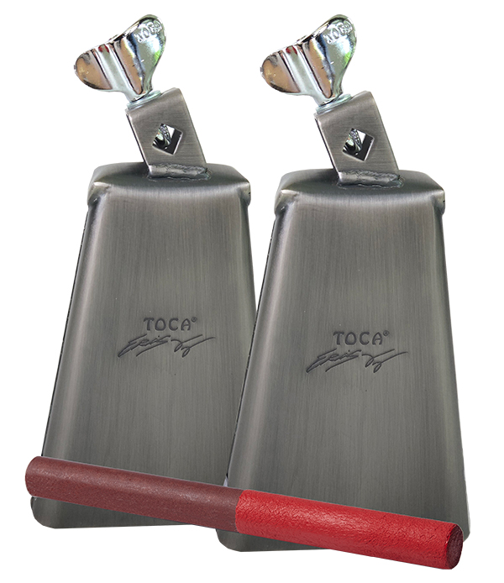
Toca Percussion is thrilled to the latest evolution of the Eric Velez Signature Nuyorican Series, bringing expanded versatility and improved playability to musicians everywhere. Designed in close collaboration with renowned percussionist Eric Velez, these updated instruments blend the soul of Puerto Rican percussion with the unmistakable energy of New York—now with features that make them accessible to even more players.

The Toca Eric Velez Signature Nuyorican Bongo Bells, originally introduced as handheld models, are now equipped with a rugged eye-bolt mounting system, allowing them to attach easily to any standard percussion rod. This enhancement opens the door for all percussionists, including drum set players, to integrate these distinctive bells into their setups. Whether adding Latin texture to pop, salsa, fusion, or any style seeking bold rhythmic color, these steel bells with their matte-silver finish deliver the unmistakable tone and character of the Nuyorican sound.

Eric Velez shares, “These bells were made to fill sounds that I couldn’t find with any other bells. Now that they can be mounted, even more musicians can explore the combination of Puerto Rican roots and New York flavor that inspired them.”

Available in High Pitch and Medium Pitch, each bell offers its own unique voice, giving players the flexibility to shape their sound with clarity and authenticity.

Also new to the lineup is an enhanced version of the Toca Eric Velez Signature Nuyorican Cowbell Beater. Maintaining its durable phenolic construction and vivid Arádano Rojo finish, the beater now features a longer handle, providing improved comfort and control—especially for percussionists with larger hands or those who prefer a more substantial grip. The handle’s size and texture ensure a secure feel during high-energy performances.

Jim Rockwell, Product Manager for Toca Percussion, adds, “We are proud to expand the Nuyorican Series with features that make Eric’s sound accessible to even more players. The new mounting system and enhanced beater reflect our commitment to giving musicians tools that are both inspiring and practical.”

tocapercussion.com
rbimusic.com

