Contact: Jim Rockwell FOR IMMEDIATE RELEASE
RBI Music
Tel: 201-247-7224
Email: jim.rockwell@rbimusic.com

Toca Percussion Introduces the All-New Conga Accessory Mount
“Why should timbale players have all the fun?”

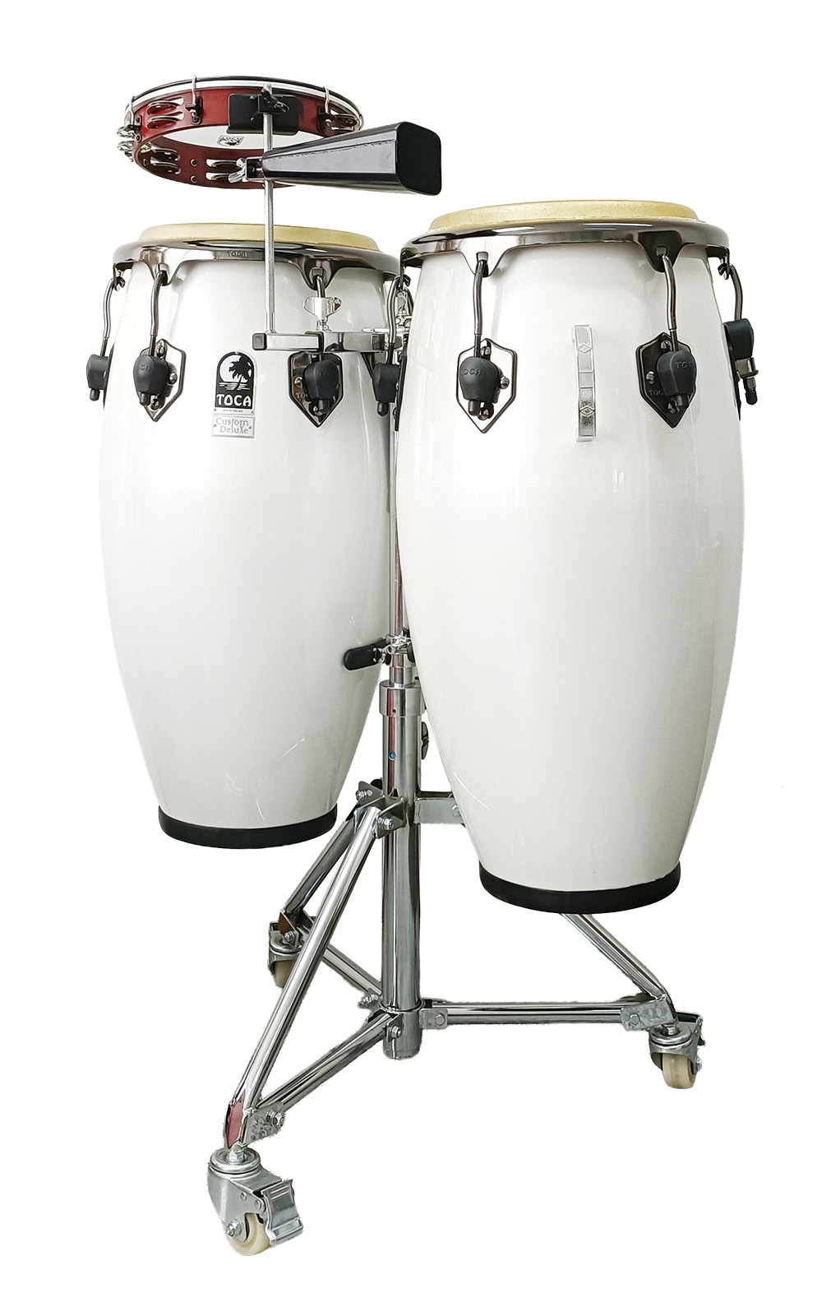
Toca announces the release of the new Toca Conga Accessory Mount, a long-awaited solution for conga players who want to expand their setup with the same ease and flexibility that timbale players have enjoyed for decades. Modeled after the accessory post found on traditional timbale stands, this innovative mount brings that familiar functionality to any double conga stand, giving conga players unprecedented freedom to incorporate additional sounds seamlessly into their performance.

The mount attaches directly to the center post of any standard double conga stand, including Toca’s Heavy-Duty Double Conga Stand. Once installed, the forward-reaching arm and upright knurled rod allow players to attach cowbells, blocks, and other percussion accessories that clamp to a knurled post. Until now, conga players had to rely on inconvenient percussion trays, complicated mic-stand rigs, or single-item rim clamps that limited creativity and added unnecessary clutter. The Toca Conga Accessory Mount eliminates all of these issues by offering a clean, stable, professional mounting solution that supports multiple accessories at once.

“Congueros deserve the same flexibility and fun that timbale players have enjoyed for years,” said Jim Rockwell, Head of Toca Product Development. “This mount gives them instant access to bells, blocks, and any other add-ons they want, right where they need them—without breaking their flow or interrupting the groove.”

Durable, practical, and designed for real-world gigging, the Toca Conga Accessory Mount opens the door to new sonic textures and performance possibilities. With this release, Toca reinforces its ongoing commitment to giving percussionists the tools they need to express themselves fully—and to do it with confidence, convenience, and style.

tocapercussion.com
rbimusic.com

