Contact: Rick Taylor
RBI Music
Tel: 817-335-2561 x105
Email: rick.taylor@rbimusic.com

The Silvertone® 852 Hula Ukulele: A Vibrant Reissue Celebrating Island Style and Vintage Silvertone Art

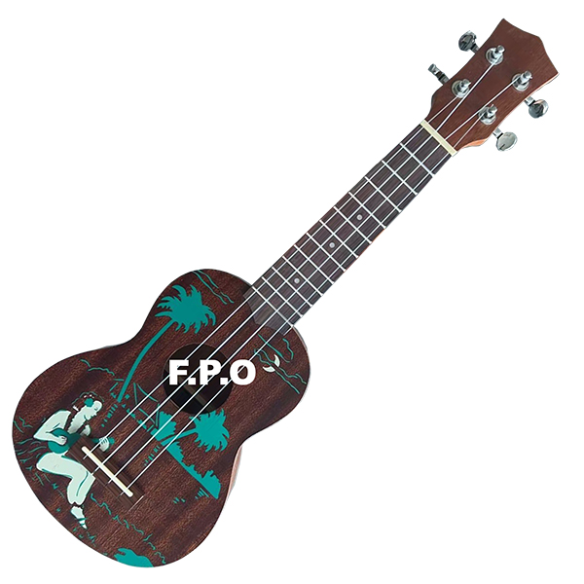
Silvertone proudly introduces the 852 Hula Ukulele, a stunning new addition to its historic line of reissued vintage instruments. Rooted in more than 100 years of musical tradition, the 852 Hula revives one of Silvertone’s most charming and sought-after, 2-color stencil-style ukulele designs—now faithfully recreated with modern reliability, vivid artwork, and the unmistakable Silvertone character players have cherished since 1914.

Silvertone’s ukulele legacy began in the Sears catalog over a century ago, inspiring generations of musicians with approachable, affordable instruments that never sacrificed personality. Over the decades, designs like the iconic “Water Skier” series helped define Silvertone’s visual identity, combining playful Americana with musical accessibility.

The new 852 Hula model carries that heritage forward with a beautifully detailed, mid-century–inspired island scene. The stencil artwork—rendered in a vibrant teal tone—depicts a classic hula dancer, palm trees, and a moonlit shoreline, all set against the ukulele’s rich brown mahogany body. The result is a design that feels authentically retro, instantly eye-catching, and unmistakably Silvertone.

Beyond its timeless look, the 852 Hula is built for today’s players. Its traditional mahogany body and neck paired with a smooth Walnut fingerboard deliver warm projection with sweet midrange presence. Modern geared tuners provide improved tuning stability, making the 852 Hula reliable on stage, in the studio or just to pick up for fun at home.

The 852 Hula continues Silvertone’s commitment to honoring the past while inviting new generations to discover the joy, creativity, and nostalgic charm of these iconic instruments. Whether you’re a collector, a longtime Silvertone fan, or a first-time ukulele player inspired by its classic artwork, the 852 Hula offers a uniquely delightful musical experience—one that celebrates a century of craftsmanship and culture.

For more information about Silvertone and its reissued ukuleles, please visit SilvertoneGuitars.com

Silvertone Guitars is a wholly owned brand of RBimusic.

