Contact: Jim Rockwell FOR IMMEDIATE RELEASE
RBI Music
Tel: 201-247-7224
Email: jim.rockwell@rbimusic.com

Grover Pro Percussion Introduces Protégé Series Timpani Mallets, Mallet Bag, and Complete Kits Designed for the Next Generation

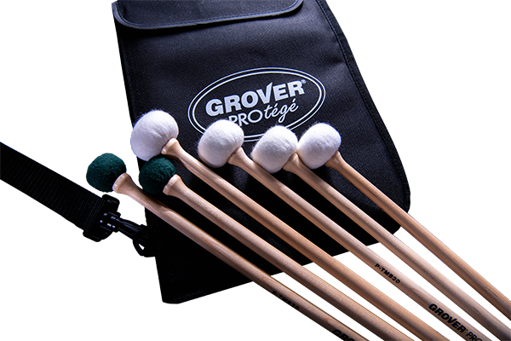
Grover Pro Percussion proudly announces the release of its new Protégé Series lineup of timpani mallets, mallet bag, and all-in-one mallet kits created specifically for the developing timpanist. Built with Grover’s hallmark commitment to quality, the Protégé Series provides students and young performers with professional-level tools designed to support their growth and musical development.

The Protégé Timpani Mallets were engineered from the ground up to help players build a strong foundation. Available in soft (P-TMB-10), medium (P-TMB-20), and hard (P-TMB-30) models, each mallet is crafted with a tapered maple handle for comfort, a durable wood core for reliable response, and hand-sewn high-quality felt that produces a clean, consistent tone. For added longevity, felt recovering kits are also available, ensuring the mallets perform at their best over time.

To support young percussionists on the move, Grover Pro introduces the new Protégé Mallet Bag. This stylish yet practical bag features three spacious mallet pockets along with additional compartments for drumsticks and accessories. A built-in shoulder strap provides hands-free carry, while the lightweight but sturdy construction makes it ideal for daily practice, rehearsals, and performances.

For students and educators seeking a complete solution, the Protégé Timpani Mallet Kit offers everything needed in one convenient package. The kit includes all three Protégé mallet models—soft, medium, and hard—each with the same tapered maple handles, durable wood cores, and hand-sewn felt found throughout the series. The included Protégé Mallet Bag keeps everything secure and organized with its trio of roomy pockets and rugged black design, making it perfect for school programs or young players building their first professional setup.

“We created the Protégé Series to give young timpanists access to high-quality tools that support real musical growth,” says Neil Grover, founder of Grover Pro Percussion. “Developing players deserve equipment that inspires confidence, and the Protégé line delivers exactly that—dependable performance, professional feel, and exceptional value.”

groverpro.com
rbimusic.com

