Contact: Jim Rockwell FOR IMMEDIATE RELEASE
RBI Music
Tel: 201-247-7224
Email: jim.rockwell@rbimusic.com

Grover Pro Unveils the New Grover Pro Mallet Rack:
The Ultimate Combination of Organization, Efficiency and Style

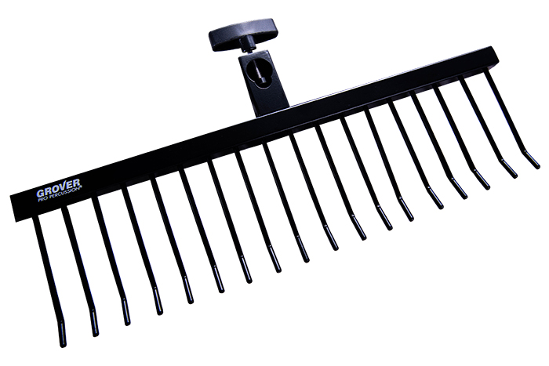
Grover Pro Percussion announces the release of the Grover Pro Mallet Rack, a game-changing addition to any percussion setup. Designed for performers who demand precision and efficiency, this highly engineered rack offers unrivaled organization, durability, and visual appeal—all in a single, sleek package.

Crafted entirely from rugged metal, the Grover Pro Mallet Rack is built to withstand a lifetime of performances, rehearsals, and touring. Its reinforced construction ensures dependable stability, eliminating the wobble and wear often associated with wooden alternatives. With the capacity to securely hold up to 17 pairs of mallets, this rack offers more storage than any other option on the market, making it the ideal choice for players who rely on fast, seamless mallet changes. A universal clamp system allows the rack to attach effortlessly to virtually any stand, giving percussionists the flexibility they need in any performance environment.

The result is a rack that is reliable, rugged, and visually striking—keeping mallets organized, accessible, and right where players need them. Whether on stage or in the studio, the Grover Pro Mallet Rack enhances both workflow and appearance, elevating any percussion setup to a truly professional standard.

Founder Neil Grover expressed his excitement about the new release, saying:
“We designed the Grover Pro Mallet Rack to solve a real problem for working percussionists. Fast mallet changes can make or break a performance, and players need equipment they can depend on. This rack delivers that reliability with a level of build quality and capacity that simply didn’t exist before.”

groverpro.com
rbimusic.com

