Contact: Jim Rockwell FOR IMMEDIATE RELEASE
RBI Music
Tel: 201-247-7224
Email: jim.rockwell@rbimusic.com

Grover Pro Unveils Revolutionary Bar Chime Mount with Fully Adjustable Tilt Mechanism

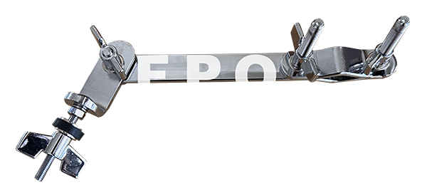
Grover Pro Percussion is happy to introduce its newest innovation: the Grover Pro Bar Chime Mount, the first and only mount to feature a fully adjustable tilt mechanism. This groundbreaking design gives percussionists complete control over bar chime placement, whether performing on stage or recording in the studio. Players can now position their chimes exactly where they need them—on a cymbal stand, boom arm, or multi-rack—making the setup more customizable than ever before.

The Bar Chime Mount is engineered for musicians who demand precision, versatility, and reliability. The exclusive tilt mechanism allows players to fine-tune their chime angle for ideal resonance and ergonomic access. Universal compatibility ensures that the mount works seamlessly with any bar chime and integrates effortlessly into existing setups, no matter how simple or complex. Designed by percussionists who understand the demands of real-world performance, the mount features the rugged, professional-grade construction needed to withstand touring, rehearsals, and studio use.

Grover Pro has long been trusted by top percussionists around the world for its commitment to unmatched craftsmanship, durability, and performance. The new Bar Chime Mount continues that legacy, offering musicians a level of control and flexibility never before available.

Quote from Grover Pro Founder Neil Grover

“Percussionists deserve gear that responds to their needs—not the other way around,” says Grover Pro Founder, Neil Grover. “Our new Bar Chime Mount was designed to give players complete control over their setup, whether in the studio or on stage. This is about empowering musicians with tools that elevate both comfort and creativity.”

groverpro.com
rbimusic.com

