Contact: Jim Rockwell Embargoed Until January 23, 2025
RBI Music
Tel: 201-247-7224
Email: marketing@rbimusic.com

Toca Expands Street Series Djembes with Two Bold New Designs

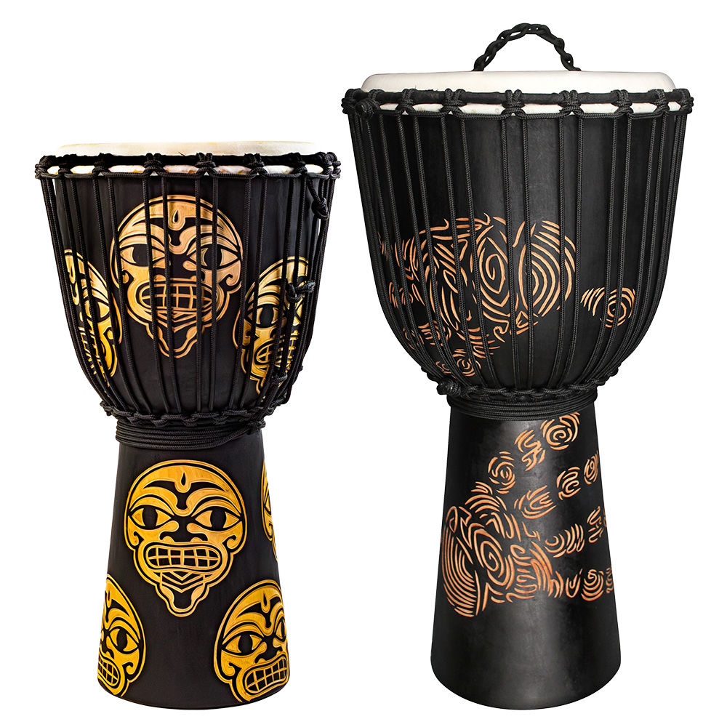
Toca Percussion is thrilled to announce the addition of two striking new designs to its beloved Street Series Djembes. Renowned for their craftsmanship and commitment to environmentally friendly practices, Toca's Street Series continues to combine exceptional sound quality with unique, artistic aesthetics. These new designs, "The Watcher" and "Handprint," are now available in three versatile sizes: 8”, 10”, and 12”.

Each djembe is hand-carved from a single piece of plantation-grown mahogany wood, ensuring sustainability and durability. The shells are kiln-dried and treated with 20 coats of teak oil to preserve and protect the wood, maintaining their beauty and performance over time. Topped with hand-selected goatskin heads and featuring authentic rope tuning, these djembes deliver a warm, resonant tone and superior playability.

"The Watcher" design features a bold, graphic design that centers on a stylized face with exaggerated features, including wide, expressive eyes and a mouth with grid-like teeth. The design is repeated around the drum’s body, creating a cohesive, rhythmic aesthetic that reflects the energy and dynamism of drumming. The contrast of earthy tones against a sleek black background gives this drum an edgy and dramatic appeal, perfect for musicians who want their instrument to make a statement.

The "Handprint" model offers a modern, textural design inspired by fingerprints. The swirling, concentric lines form a bold handprint motif that appears to grip the drum, symbolizing the human connection to rhythm. The natural, warm tones of the design stand out vividly against the drum's black background, creating a sense of movement and energy that resonates with the dynamic nature of percussion.

"Toca’s Street Series Djembes are already known for their quality, tone, and artistry, and these two new designs push the boundaries even further," said Jim Rockwell, Toca Product Manager. "‘The Watcher’ is bold and dramatic, while the ‘Handprint’ brings a personal, tactile feel to the series. These djembes are not only instruments but works of art that speak to the passion of drummers and the timeless connection to rhythm."

tocapercussion.com

