Contact: Rick Taylor
RBI Music
Tel: 817-335-2561 x105
Email: rick.taylor@rbimusic.com

Silvertone® Releases New 1373 Baritone Guitar: A Modern Twist on a Classic Model

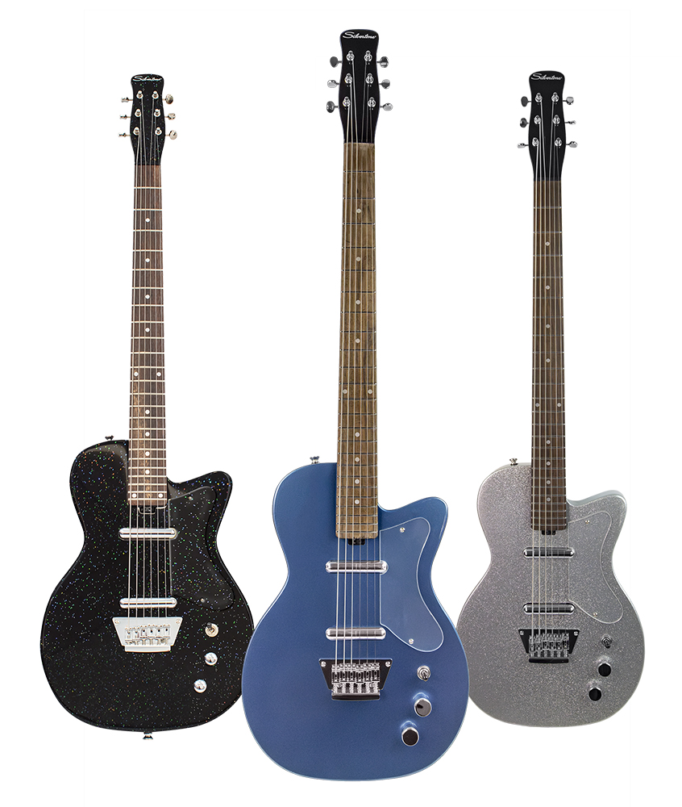
Silvertone Guitars proudly introduces the 1373 Baritone, a contemporary reimagining of the iconic 1958 6-string bass.

In 1958, Silvertone made waves with the revolutionary 1373 model, a 6-string bass tuned low E to E, paving the way for the distinctive tic-tac technique in Nashville. This technique involved doubling acoustic bass lines with the six-string bass played with a pick. This unique tuning was also famously featured in Glen Campbell&apos;s iconic six-string bass solo on the hit single "Wichita Lineman."

With the 1373 Baritone, Silvertone pays homage to this rich history by transforming the instrument into a baritone tuning marvel. The 28” scale neck is meticulously designed for B to B tuning, echoing the popular baritone tuning that left an indelible mark on 1960s surf rock and spaghetti western soundtracks.

Crafted with a solid mahogany body, the 1373 Baritone delivers unparalleled punch and sustain. The string-through body bridge enhances resonance, and the 28” scale strikes the perfect balance, allowing the lower strings to resonate authentically without sacrificing the comfort of standard tuning guitars.

Equipped with the new Alnico 5 Silvertone Lipstick pickups, the 1373 Baritone retains the clean tones and bell-like top end of the original pickups, with a bit more output. This additional output provides the flexibility to comfortably drive pedals, tube amps, or digital modelers, making the 1373 Baritone a versatile instrument across various musical genres.

The 1373 Baritone is available in three striking colors: Black Silver Flake, Pelham Blue, and Silver Metal Flake.

For more information about Silvertone, please visit SilvertoneGuitars.com
Silvertone Guitars is a wholly owned brand of RBimusic.

