Contact: Jim Rockwell For Immediate Release
RBI Music
Tel: 201-247-7224
Email: jim.rockwell@rbimusic.com

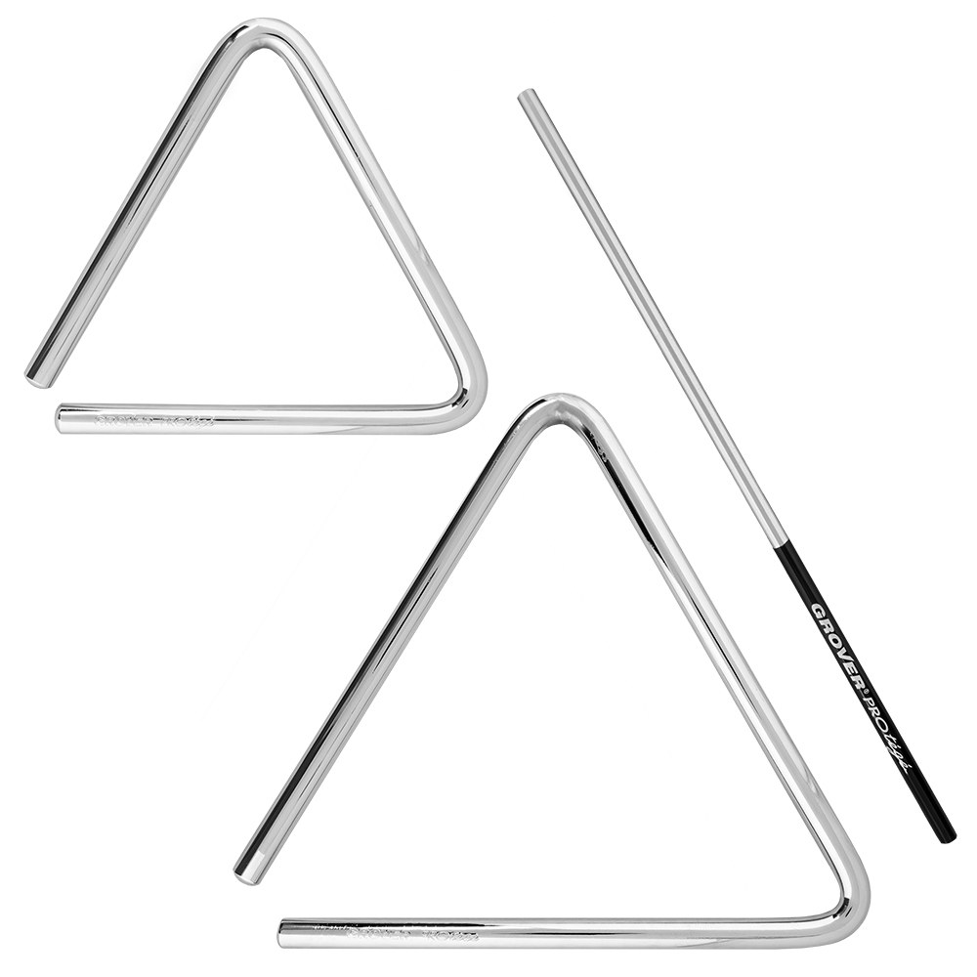
Grover Pro Expands Protégé Series with Triangles and Beater
Grover Pro, is excited to announce the latest additions to its Protégé series, originally introduced in 2024. Joining the line’s existing tambourines and wood blocks are the Protégé Triangles and Beater, offering percussionists outstanding sound quality and versatility at an accessible price point.

The Grover Protégé Triangles, available in 6" and 8" sizes, continue the series' tradition of exceptional craftsmanship. Made from premium steel, these triangles resist corrosion while preserving the natural overtone spectrum for a shimmering, dynamic tone. The 6" model delivers a versatile sound with a clear, bright tone suited for general use. The 8" triangle offers greater projection and body, ideal for applications requiring a bolder, fuller sound. Both sizes produce a consistent overtone spectrum across their entire dynamic range.

Completing the expansion is the Grover Protégé Beater, designed to pair seamlessly with the triangles. Crafted from a stainless-steel alloy, the beater minimizes contact noise while producing a rich, articulate sound. Its extra-long 8.9” length and 7/32” diameter make it perfect for executing intricate rhythms and rolls with ease, while the Easy Grip handle ensures comfort during extended performances.

Neil Grover, Founder of Grover Pro Percussion, shared his thoughts on the new additions: “The Protégé series has been a game-changer, offering professional-grade instruments that are accessible to musicians at all levels. With the addition of the triangles and beater, we’re continuing to expand the possibilities for percussionists looking for quality and reliability without compromise.”

groverpro.com
rbimusic.com

