Contact: Jim Rockwell FOR IMMEDIATE RELEASE
RBI Music
Tel: 201-247-7224
Email: jim.rockwell@rbimusic.com

Toca Unveils Eric Velez Signature Nuyorican Handheld Bongo Bells & Beater
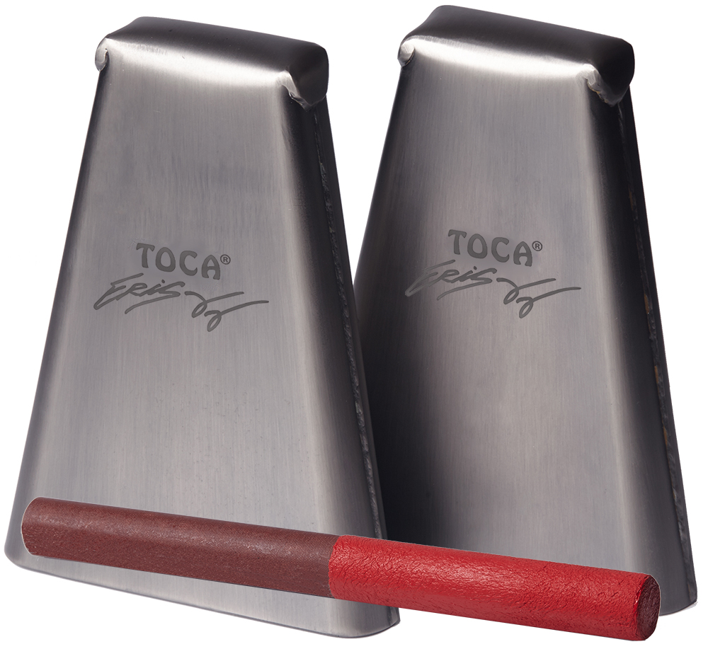
Toca Percussion is thrilled to introduce the Toca Eric Velez Signature Nuyorican Handheld Bongo Bells—a fusion of Puerto Rican and New York percussion styles. Designed in collaboration with renowned percussionist Eric Velez, these bells are crafted to complement his signature series timbales, bringing the vibrant rhythms of Island Salsa and New York flair to musicians worldwide.

The Nuyorican Handheld Bongo Bells capture the essence of Latin Pop, Modern Salsa, and any genre that seeks to infuse a touch of Latin flavor into its sound. Made with steel bells finished in matte silver, these handheld bells deliver a distinctive auditory experience.

Eric Velez, expressing his passion for the project, remarks, "These bells were made to fill sounds that I couldn't find with any other bells. They bring together the soul of Puerto Rican and New York percussion scenes, creating a unique sonic palette for musicians."

The Toca Eric Velez Signature Nuyorican Handheld Bongo Bells are available in two models: High Pitch and Medium Pitch. Each model is meticulously crafted to offer distinct tones, providing percussionists with versatile options to enhance their performances.

The Toca Eric Velez Signature Nuyorican Cowbell Beater has been meticulously crafted to meet the Eric’s exacting standards. This exceptional beater is constructed from phenolic, showcasing a robust and durable design. The handle is expertly applied, resulting in a secure and comfortable grip. The vibrant Arádano Rojo color of the handle perfectly complements Eric's latest congas, bongos, and timbales, creating a visually cohesive and dynamic percussion setup.

Jim Rockwell, Marketing & Product Manager for Toca Percussion, states, "We are thrilled to collaborate with Eric Velez on these exceptional bells. They represent the spirit of Island Salsa blended with the energy of New York, offering musicians a distinctive tool to elevate their musical expressions."

tocapercussion.com
rbimusic.com

