**Contact:** Rick Taylor

RBI Music

**Tel:** 817-335-2561 x105

**Email:** [rick.taylor@rbimusic.com](mailto:rick.taylor@rbimusic.com)

**Silvertone® proudly unveils a nostalgic journey through time with the reissue of its iconic ukulele series!**

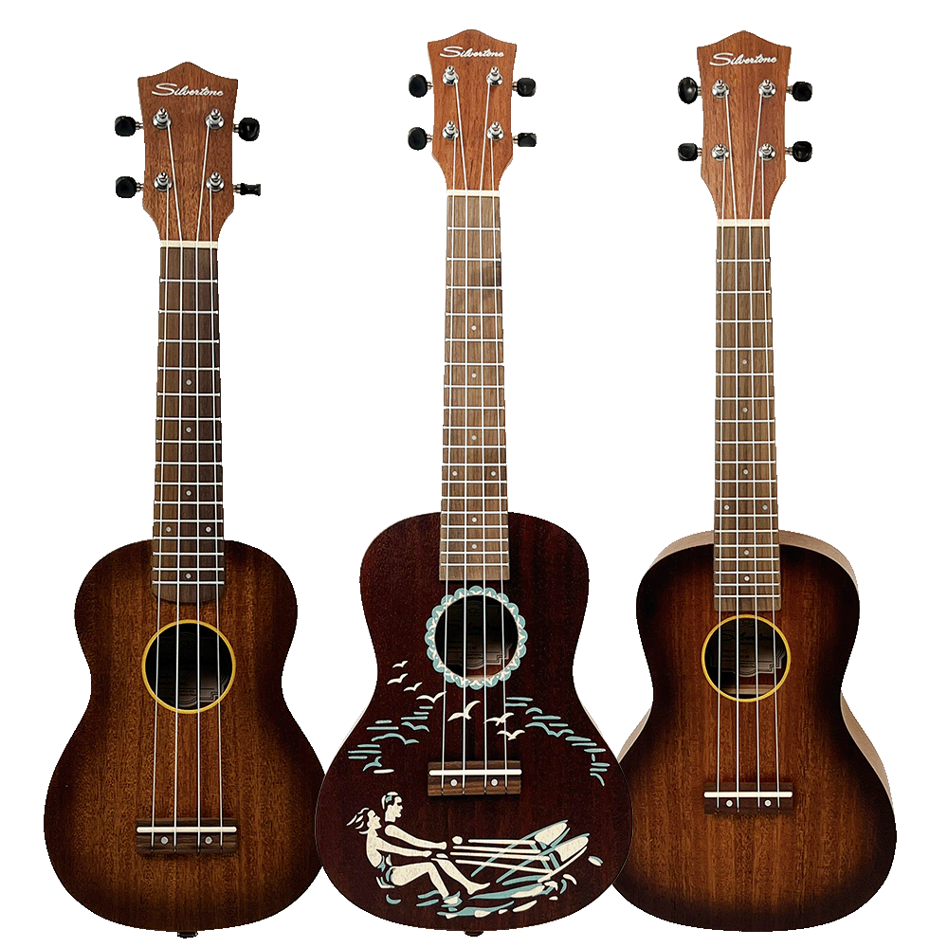Rooted in a century-old legacy, Silvertone's ukuleles, once featured in the Sears catalog, have left an indelible mark on the world of music since their inception in 1914.

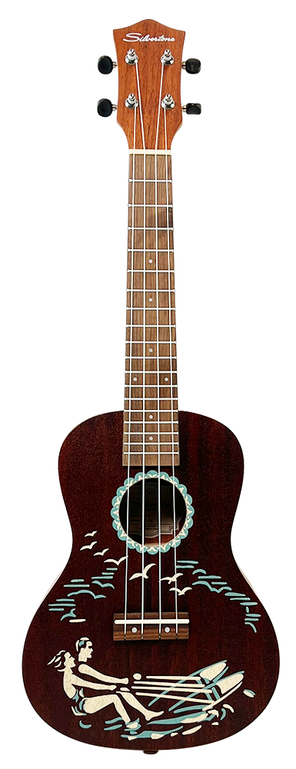The Silvertone ukulele saga began with the introduction of the first ukulele in the Sears catalog, capturing the hearts of music enthusiasts over a century ago. The 'Water Skier' series, adorned with a one-color stenciled design, made its debut in 1937 under the original Supertone name, reappearing in 1956 with a captivating two-color graphic under the Silvertone brand.

In 1947, the Silvertone 851 emerged, marking the start of a series that would resonate through the decades. The 853 Concert Size Ukulele, introduced in 1950, quickly became a best-seller with its luxurious mahogany body, Rosewood fingerboard, and waterproof nylon strings. The return of the 'Water Ski' stenciled uke in 1956 further solidified Silvertone's place in musical history.

Silvertone's commitment to preserving the essence of these iconic ukuleles is evident in the reissued 851, 853, and 854 models. Each reissue carefully balances the mojo of the original versions with modern upgrades, enhancing tuning stability and playability, mirroring the success of Silvertone Electric and Acoustic guitars.

The Silvertone 851 Hawaiian-scene 'Water Skier' Concert Size Ukulele, originally available from 1956, makes a triumphant return with a brilliant recreation of the 2-color stenciled body. The reissue features an 18-fret fingerboard, mahogany construction, and modern geared tuners, ensuring reliable intonation. The traditional mahogany body and neck, coupled with a Walnut fingerboard, deliver excellent projection and thick, well-defined bass tones, recreating the magic of the original.

The Silvertone 853 Concert Size Ukulele, a best-seller from 1950 to 1970, is reborn with an 18-fret fingerboard and modern geared tuners for reliable intonation. The 50's style brown sunburst satin finish adds a nostalgic touch, paying homage to the era when ukuleles were a cultural phenomenon. The traditional mahogany body and neck, along with a Walnut fingerboard, promise exceptional projection and rich bass tones.

Introduced in 1965, the Silvertone 854 Soprano Size Ukulele captivates with its 15-fret fingerboard, modern geared tuners, and a 50's style brown sunburst satin finish. The reissue features a traditional mahogany body and neck, coupled with a Walnut fingerboard, providing excellent projection with sweet and punchy midrange tones.

Silvertone's reissued ukuleles are a testament to the brand's commitment to quality, tradition, and the enduring appeal of these timeless instruments. As Silvertone continues to shape the musical landscape, the reissued ukuleles invite both seasoned musicians and new enthusiasts to experience a lifetime of enjoyment and creativity.

For more information about Silvertone and its reissued ukuleles, please visit [**SilvertoneGuitars.com**](https://silvertoneguitars.com/)

About Silvertone:  
Silvertone, with a legacy spanning over a century, stands as a symbol of musical craftsmanship and innovation. Renowned for its guitars and ukuleles, Silvertone continues to shape the musical landscape with instruments that blend tradition with modernity. The reissued ukulele series pays homage to the brand's rich history, promising a timeless experience for musicians worldwide. For more information, visit [website].

Silvertone Guitars is a wholly owned brand of RBimusic.