**Embargoed Until November 15, 2024**

**Contact:** Rick Taylor

RBI Music

**Tel:** 817-335-2561 x105

**Email:** [rick.taylor@rbimusic.com](mailto:rick.taylor@rbimusic.com)

**Silvertone® Guitars Unveil New Twin Trem™ Pedal**

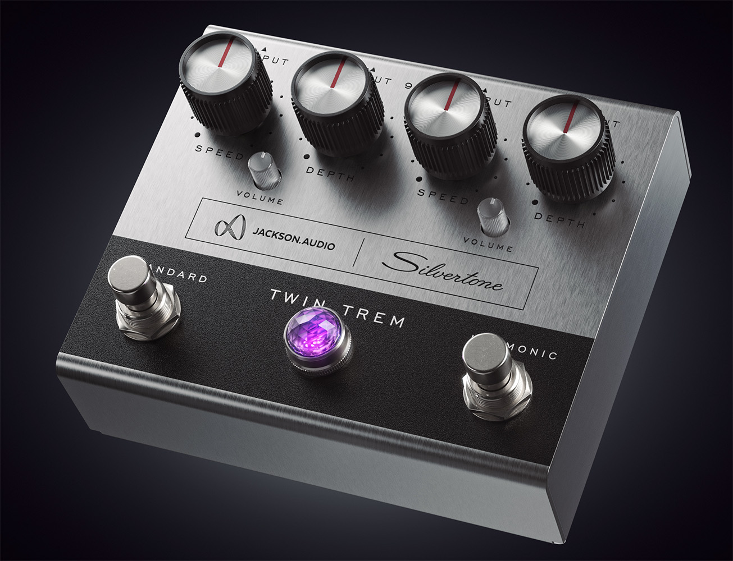Following the acclaimed 2022 release of the Silvertone Twin Twelve® effects pedal, Silvertone Guitars proudly introduces the all-new Silvertone Twin TremTM pedal. This innovative pedal is inspired by the unique tonal character of the legendary Silvertone 1484 Twin Twelve amp, a go-to choice for many of today’s most creative artists. As with the original Twin Twelve, Jackson Audio is, once again, responsible for all aspects relating to engineering & manufacturing of the pedal.

One of the standout features of the original 1484 Twin Twelve amp is its lush, tube-driven tremolo. The new Twin Trem pedal meticulously recreates this iconic sound, bringing the classic Silvertone vibe to a pedalboard-friendly format. But this pedal is more than just a reissue—it’s an evolution. The Silvertone Twin Trem features two completely independent tremolo circuits, each offering distinct tonal possibilities.

The left side of the pedal recreates the original Silvertone optical tremolo circuit, delivering the vintage pulse that made the 1484 Twin Twelve amp famous. The right side introduces a modern take on an early 1960s-style harmonic tremolo, known for its rich and complex modulation. These two circuits can be used together or independently, offering musicians a versatile tool for creating unique, otherworldly soundscapes.

The Twin Trem pedal is equipped with independent input and output jacks for each tremolo circuit, allowing players to further experiment with routing options. For example, placing the harmonic tremolo before a reverb effect and routing back to the optical tremolo after reverb can recreate the original 1484 signal chain. And, with a stereo setup players can combine the two independent circuits for stunning spatial effects.

“We’re thrilled to continue our partnership with the fantastic engineers at Jackson Audio which allows us to bring another piece of Silvertone history to life,” said Rick Taylor, Guitar Product Manager at Silvertone Guitars. “The Twin Trem captures the essence of the original 1484 amp’s tremolo while adding new features that modern players will love. Whether used individually or together, these two tremolos open up a whole new dimension of creative possibilities.”

For more information about Silvertone, please visit [**SilvertoneGuitars.com**](https://silvertoneguitars.com/)

Silvertone Guitars is a wholly owned brand of RBimusic.