**Contact:** Jim Rockwell **FOR IMMEDIATE RELEASE**

**RBI Music**

**Tel:** 201-247-7224

**Email:** jim.rockwell@rbimusic.com

**Grover Pro Unveils Two Tambourines for Discerning Musicians**

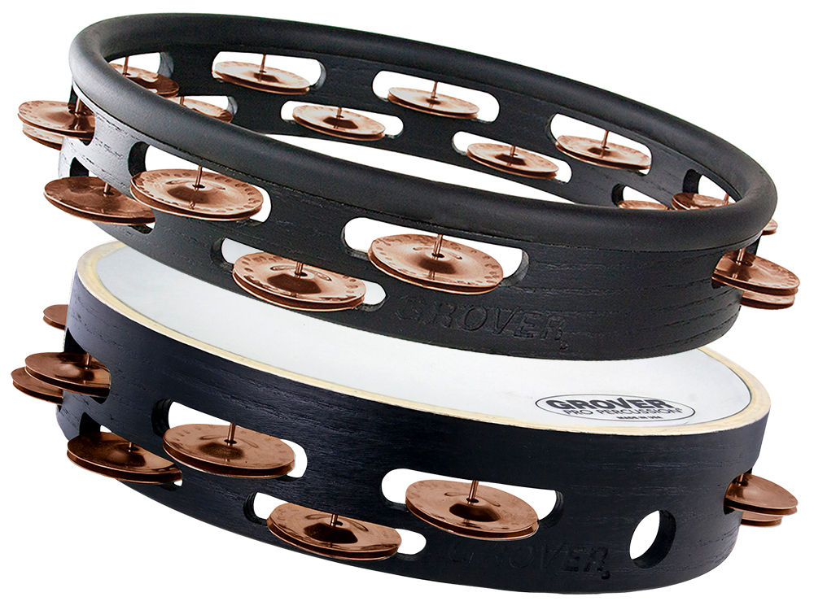

Grover Pro Percussion, a trailblazer in the world of percussion instruments, is proud to introduce two new additions to its esteemed lineup – the Model T2/BC-H Headless Tambourine and the Model T2-PhBr-X Tambourine. These cutting-edge tambourines showcase Grover Pro's commitment to precision craftsmanship and innovative design, catering to the diverse needs of musicians around the globe.

First up is the Studio Pro Model T2/BC-H headless tambourine. Designed with the recording percussionist in mind, it features the renowned Beryllium Copper hand-hammered jingles, synonymous with Grover Pro's professional concert tambourines. With a headless design, this tambourine is a valuable addition to the Studio Pro line, already celebrated and favored by artists such as Taylor Swift, Jason Aldean, Jimmy Buffet, and more, making it the preferred choice in Nashville and LA recording studios.

Other notable features of the T2/BC-H include dual-width staggered jingle slots for optimal sound projection, soft rubber comfort edging for enhanced playability and a 10" diameter durable hardwood shell, along with the Grover Pro guarantee of quality.

The individually hammered and voiced Beryllium Copper jingles produce a full-bodied, rich sonority, while maintaining the percussive articulation necessary to cut through the dense mix of a large live performance session. As a testament to Grover Pro's commitment to quality, each Studio Pro tambourine comes with a free padded tambourine case for added protection.

Next up, for musicians in humid climates, Grover Pro presents the Model T2-PhBr-X tambourine, designed to maintain stability in all playing conditions. This X-Series model features a synthetic head made from Remo Renaissance® material, ensuring optimal performance regardless of humidity or temperature changes. The Phosphor Bronze model, a favorite among percussionists seeking a deep, darker sound color, complements romantic European orchestral repertoire and is equally suited for concert bands or small ensembles.

Other notable features of the T2-PhBR-X include dual-width staggered jingle slots for optimal sound projection, a Remo® synthetic head for stability in varying conditions, and a 10" diameter durable hardwood shell, along with the Grover Pro guarantee of quality. A free tambourine bag is also included.

Neil Grover, Founder of Grover Pro Percussion, stated, "These tambourines showcase our dedication to innovation and quality. We believe they will empower musicians to achieve their best performances, whether in the studio or on stage."

groverpro.com

rbimusic.com