**Contact:** Jim Rockwell **FOR IMMEDIATE RELEASE**

RBI Music

**Tel:** 201-247-7224

**Email:** marketing@rbimusic.com

**Toca Releases Innovative Grabber Percussion Mount for Easy Customization of Drum Sets**

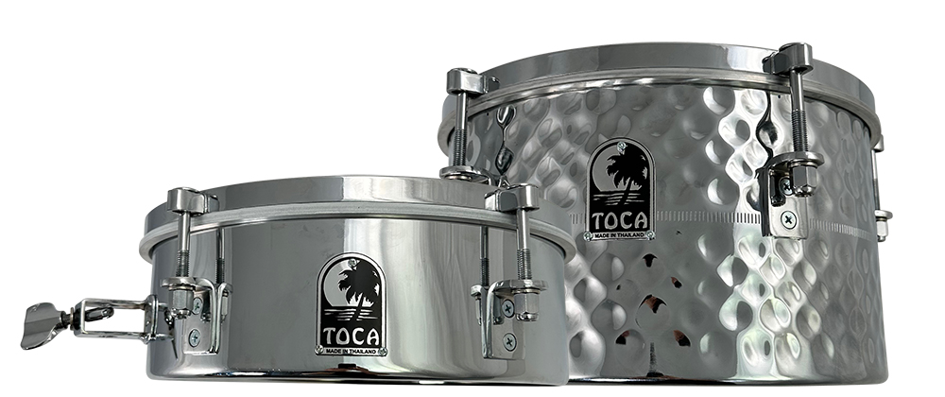Toca Percussion, one of the leading companies in the world of hand percussion, has launched the Toca Grabber Percussion Mount. The percussion mount is designed to easily add percussion or small cymbals to drum sets, congas, or timbales. The Grabber can be securely mounted on any common drum rim to add percussion accessories, or microphones exactly where they're needed. The mount is also ideal for drum kit set-ups, percussion rigs, and even marching drums. The Grabber comes equipped with a standard percussion rod that is angle adjustable to fit your exact needs.

One of the key features of the Toca Grabber is its ability to fit nearly every standard drum rim, making it a versatile addition to any drummer or percussionist's toolkit. This percussion mount securely holds accessories or microphones, and is height adjustable to ensure perfect placement of the equipment. The Grabber's angle adjustability allows the user to position their accessories at any angle they require.

"With the introduction of this mount Toca is making a commitment to its drummers and percussionist to make customizing their percussion rigs a breeze,” said Jim Rockwell, Marketing & Product Manager for Toca Percussion. "It’s simple and quick to use, it’s height adjustable, angle adjustable, and will hold just about any drum accessory that fits a standard percussion rod.”

The Toca Grabber Percussion Mount is an exciting new product that promises to make customization of drum sets and percussion rigs much easier and more efficient. With its versatility and ease of use, the Toca Grabber is sure to become an essential accessory for drummers and percussionists around the world.

tocapercussion.com

rbimusic.com