Contact: Jim Rockwell FOR IMMEDIATE RELEASE
RBI Music
Tel: 201-247-7224
Email: marketing@rbimusic.com

Control those Jingle Sounds on Your Kit with the Toca Jingle Snap™

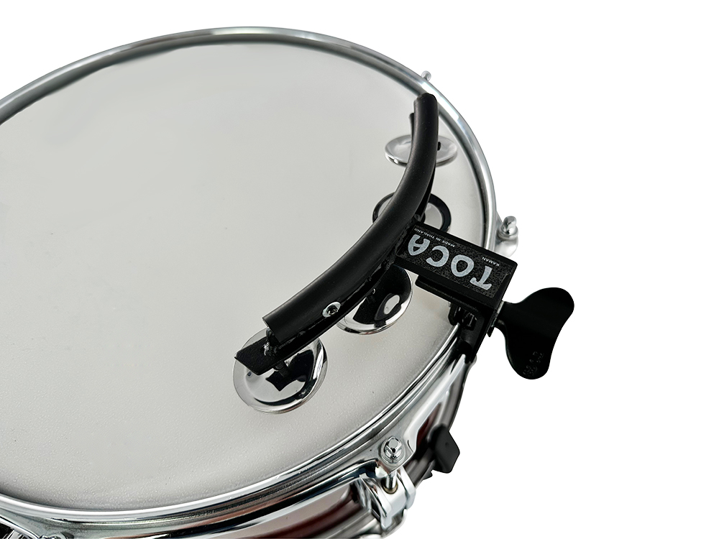
Toca Percussion is proud to announce the Toca Jingle Snap™. This innovative accessory allows drummers to add a jingle sound to their backbeat with precision and control.

With the Toca Jingle Snap, drummers can keep access to that jingle sound close to their sticks and hit it whenever they want. This stickable jingle provides a precise accent only when needed, because it’s mounted directly onto the snare instead of to a constantly moving hi-hat. This small accessory packs a big sound or quiet jingle, and leaves the drummer in control.
Designed to fit onto any acoustic drum, the Toca Jingle Snap™ features four nickel-plated steel jingles that add texture. Its black powder-coated metal frame ensures durability and long-lasting use.

“The Toca Jingle Snap is the perfect addition to any drummer's kit," said Jim Rockwell, Toca Marketing and Product Manager. "We understand the importance of control and precision when it comes to drumming, and this accessory provides just that.”

tocapercussion.com
rbimusic.com

