**Contact:** Jim Rockwell **FOR IMMEDIATE RELEASE**

RBI Music

**Tel:** 201-247-7224

**Email:** marketing@rbimusic.com

**Toca Introduces Commuter Congas – Multiple Sizes and Expanded Sound Range**

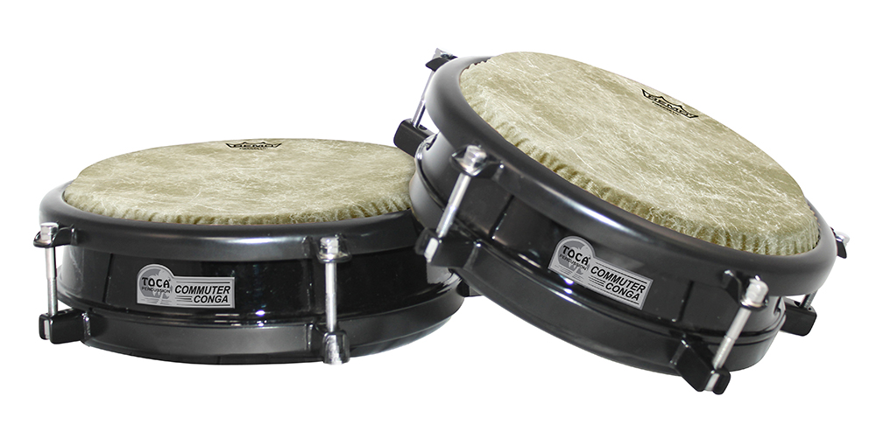Toca, a leading manufacturer of percussion instruments, has introduced the Commuter Conga, a portable drum that is perfect for musicians on the go. The Commuter Conga is available in 10” and 11” head sizes and comes standard with Remo Fiberskyn heads.

Musicians can purchase drums separately or choose from one with a single stand or both sizes with a double stand. The lugs are accessible at the top, making it simple and quick to adjust the sound and tuning.

The 10” drum comes with a 3” diameter port on the bottom, allowing the highs to ring loud and true while letting the slaps come through. On the other hand, the 11” drum comes with a 6” diameter port on the bottom, allowing for astonishing mid-tones and just the right amount of bass.

Both single and double stands are made from heavy-duty steel and feature an adjustable arm that holds either size of the Commuter Conga in tight. Musicians can even add a third Commuter Conga to get a true Quinto, Conga Tumba set up.

“We are excited to introduce the Commuter Conga to our line of percussion instruments,” said Jim Rockwell, Toca Marketing and Product Manager. “It’s a new twist on an idea that has been around for for quite some time. We are offering a much broader sound pallete in a very small package at an affordable price. It could just be the the ultimate portable conga. It’s perfect for musicians who are contstantly running from gig to gig, or are playing gigs where space and weight are at a premium. And It's a great add-on for drum set players too!”

tocapercussion.com

rbimusic.com