**Contact:** Jim Rockwell **FOR IMMEDIATE RELEASE**

RBI Music

**Tel:** 201-247-7224

**Email:** marketing@rbimusic.com

**Toca Celebrates 30th Anniversary with Limited Edition Congas, Bongos and Cowbells**

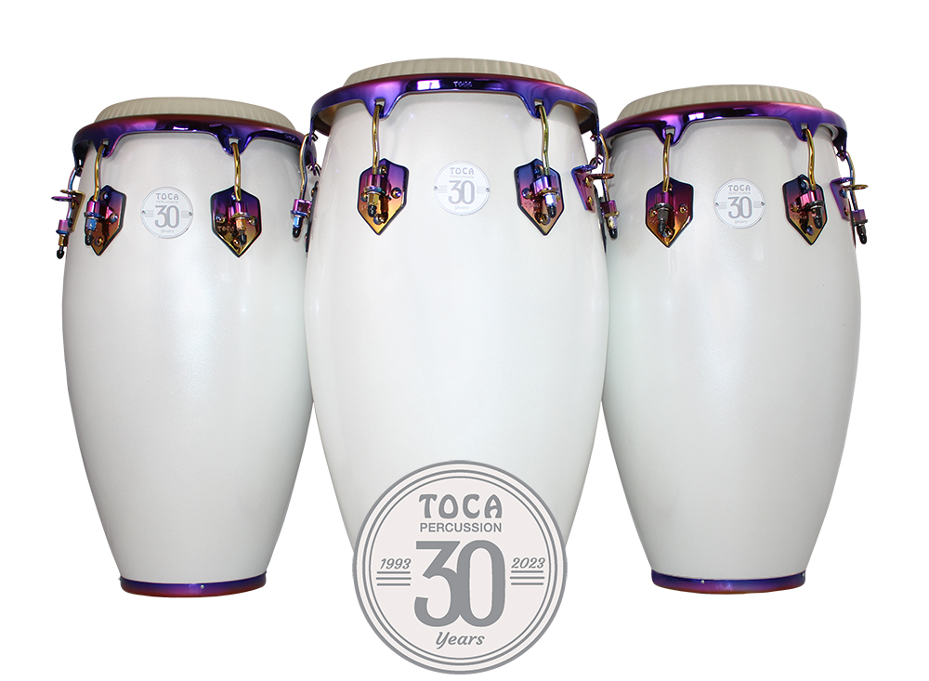Toca Percussion, one of the world's top hand percussion companies, is proud to celebrate its 30th anniversary with the introduction of the Limited Edition Margarita Congas, Bongos and Cowbells. These instruments feature luminescent shells that are richly adorned with one-of-a-kind anodized hardware, topped with white Remo® Nuskyn® heads and finished off with the 30th anniversary logo on the heads and nameplates. The drums have 28" tall, seamless fiberglass shells. The bigger belly shape produces deeper bass tones and crisp highs.

The bodies of the 30th Anniversary Cowbells mimic the luminescent shells of the drums and come in both bongo and timbale bell versions. The classic 30th Anniversary logo is adorned on the face of each bell, making all these products predestined to become collectors’ items.

Toca Percussion was founded in 1993 by KMC Music during the heyday of the Latin and Afro-Cuban influence on popular music and rock n’ roll. Toca Percussion was designed to provide the "Afro-Cuban" sound and to offer a different look for hand percussion instruments. Over the past three decades, Toca Percussion has become one of the top hand percussion companies in the world with a line of well over 500 products.

"We are excited to celebrate our 30th anniversary with the introduction of these limited edition drums and bells," said Brad Kirkpatrick, President of RBI. "These instruments are a testament to our commitment to offering a distinctive choice in style, design, and sound. We believe these stunningly beautiful 30th Anniversary drums and bells will become collectors’ items and we encourage everyone to grab theirs quickly."

tocapercussion.com

rbimusic.com