**Contact:** Jim Rockwell **FOR IMMEDIATE RELEASE**

**RBI Music**

**Tel:** 201-247-7224

**Email:** marketing@rbimusic.com

**Grover Pro Announces New GCX™ Snare Drum**

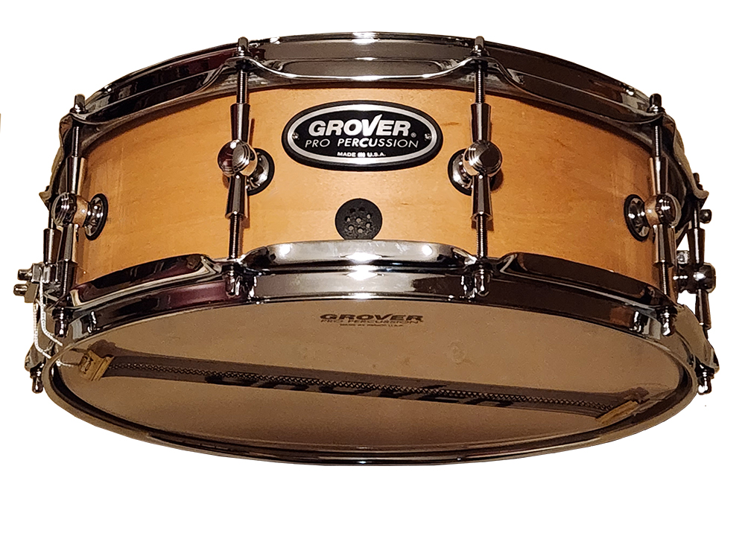Grover Pro has announced the GCX™ Concert Snare Drum, a snare drum that is both simple to use and sounds amazing. The GCX is designed specifically for percussionists who are still learning their craft, making it the simplest and most forgiving concert snare drum available.

The GCX has been engineered to produce refined crystal-clear clarity and super-sensitivity that aids in the execution of the softest dynamic passages. It features professional caliber multi-tonal CX snares that are pretensioned at the factory and never need balancing, ever! Additionally, the innovative “RADIAL” bearing edge provides more contact between the batter head and shell, bringing sonic clarity in the softer dynamic range.

One of the key features of the GCX is its “2-Tone” MAGNETIC muffler, which is the only snare drum muffler that features this technology. The muffler instantly locks into the optimal position thanks to internal rare earth magnets, providing two distinct dampening surfaces which result in different degrees of muffling. Whether you like it extra dry, or with a splash of resonance, the muffler is there to provide the perfect sound.

The GCX also includes a 10-ply cross laminated all maple shell, distinctive single point “bow tie” lugs, ADV nodal venting, a simple single lever throw-off, and a free heavy-duty case. The drum's philosophy is that less is more, so it has only one tension knob adjustment, making it incredibly easy to play.

Grover Pro founder Neil Grover said, “Percussion students have enough to worry about when they perform, they should not have to be concerned with adjusting complicated “multi-sonic” snare systems”. The GCX concert snare drum is affordable and provides a professional sound without the complexity or price-tag of expensive multi-sonic drums.

Experience the simplicity and amazing sound of the GCX concert snare drum and take your playing to the next level!

groverpro.com

rbimusic.com