**Contact:** Jim Rockwell **FOR IMMEDIATE RELEASE**

RBI Music

**Tel:** 201-247-7224

**Email:** marketing@rbimusic.com

**Toca Synergy Deluxe Wood Congas – Entry Level in Price Only!**

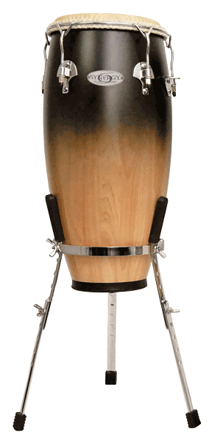Taking entry-level percussion to new heights, Toca Percussion announced the arrival of their new Synergy Deluxe line of congas. Building on Toca’s hugely popular Synergy™ line of drums, Synergy Deluxe adds superior upgrades in a thrifty package. Enhancements include REMO® Tucked Fiberskyn® heads, low-contact hoops, an elegant satin fade finish, chrome hardware and included adjustable chrome basket stands.

“The upgraded heads alone are worth the difference in cost, and that’s just the beginning!” notes Lane Davy, RBI EVP of Sales and Marketing. “Add in the nicer hardware and finish and these drums are a great value.”

Like the standard Synergy congas, Synergy Deluxe drums are 28 inches tall, made from 2-ply Asian Oak staves and sold as a set of 10” and 11” drums. However, with Synergy Deluxe, percussionists have the option to add a matching 12” Tumba. Synergy Deluxe models are available in several colors including Coffee Fade, Purple Fade, Wine Fade and Natural. All drums feature a satin finish.

tocapercussion.com

rbimusic.com