**Contact:** Jim Rockwell **FOR IMMEDIATE RELEASE**

RBI Music

**Tel:** 201-247-7224

**Email:** [marketing@rbimusic.com](mailto:marketing@rbimusic.com)

**Toca Announces New Sympatico™ System – All the Sound; Half the Weight!**

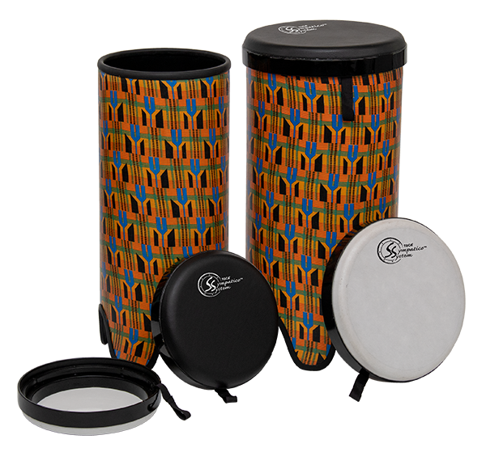

Toca Percussion is pleased to announce an amazing evolution to its line of Nesting Drums. The new Sympatico™ System of tunable, interchangeable drums and heads will change how lightweight drums are perceived. By design, lightweight drums must be portable, durable and, well, light, easy to carry and transport. Unfortunately, the most common way to achieve this desired outcome is to eliminate bulky and heavy tuning mechanisms. In their place is a pre-tuned head. It does the job, it is definitely light, and durable, but the sound is what you get.

What if you didn’t have to choose between tunable, but heavy, drums and light, but un-tunable, drums? The Sympatico System solves the issue with its innovative, and proprietary, internal tuning design. It’s significantly lighter than traditional tuning systems, and easy to use, and there’s no extra bulky, heavy, hardware attached to the side of the drum to get in your way. In fact, it’s hidden inside! And the heads are designed to simply integrate with Toca’s existing line of Freestyle II Nesting Drums including Djembes, Tom-Toms, Djun-Djuns & Ashikos. If you already have one of these instruments, pop on a new Sympatico tunable head and bring your playing, your sound, to a whole new level.

Toca is also introducing two new Freestyle II Nesting Drum series that will come standard with the Sympatico tunable head. A set of Gathering Drums and our exclusive Tubadoras, which sound like traditional congas. The sound is at once amazing and, by virtue of the ability to tune, uniquely your own. At much less than half the weight of traditional hand percussion drums.

“This is a very exciting development for hand percussion instruments,” says Brad Kirkpatrick, President of RBI Music, Toca’s parent company. “Toca has a long history of bringing innovation to the market, but this has the potential to truly change the lightweight drum sector in a distinctive way. This system can turn a category of drums that has traditionally been for education and recreational use into instruments that truly are for every level of musician”

[tocapercussion.com](http://www.tocapercussion.com)