**Contact:** Jim Rockwell **FOR IMMEDIATE RELEASE**

RBI Music

**Tel:** 201-247-7224

**Email:** [marketing@rbimusic.com](mailto:marketing@rbimusic.com)

**Toca Signs Rubén Blades Percussion Section Trio of Jose Ramon Guerra, Daniel Jimenez and Raúl Rivera!**

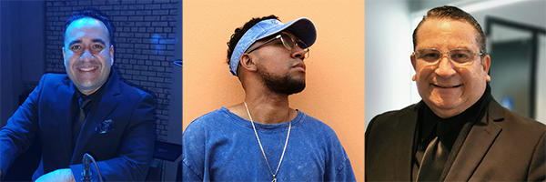Toca Percussion is pleased to announce the signing of not one, not two, but three percussionists playing with one of the most iconic performers in the salsa and Latin jazz genres, the world renown musician, composer actor and activist, Rubén Blades.

**Jose Ramon Guerra** is a percussion teacher and school band instructor as well as a percussionist and chorus musician, with more than 25 years of experience. He has been involved with the Orquesta Sociedad Anónima for more than 15 years, accompanying international musicians such as Richie Ray and Bobby Cruz, Larry Harlow, Danny Rivera, and many more. He is currently a Percussionist Musician (Conguero) and Chorus of the Roberto Delgado Orchestra which accompanies Master Rubén Blades. He won two Latin Grammys in 2021 with the Maestro Rubén Blades. Jose “is very excited to be endorsing Toca Percussion’s innovative products. It makes my sound both in the studio and live on stage complete!”

**L-R: Jose Ramon Guerra, Daniel Jimenez, Raúl Rivera**

**Daniel Jimenez** has shared the stage with and accompanied international artists in the Salsa and Latin Scene such as Wichy Camacho, Ricky Luis (N’klave), Frankie Vasquez, Gilberto Santa Rosa and many others. In 2014, he won 1st place in the "El Rey del Timbal" contest and in 2015, he won 1st place at the "La Fiesta del Tambor" in the Drums category. From 2015 to 2019 he directed his first musical project along with other colleagues and musical friends called MecaniK InformaL. That group combined Salsa, Cuban Timba and the Urban sounds of Panamanian reggae music. Currently he is the drummer of the Roberto Delgado Orchestra, the backing band for Rubén Blades. He won two Latin Grammys in 2021 with the Maestro Rubén Blades. Daniel says, “I’m humbled to be a member of the Toca family and to be included on the roster with all these amazing drummers and percussionists!”

**Raúl “toto” Rivera** is a professional percussionist from Panama and has been performing with Rubén Blades since 2015. Previous to scoring that gig, Raúl has perfromed with a who’s who of salsa and Latin jazz artists such as Ismael Miranda, Cheo Feliciano, Pedro Arroyo, Gilberto Santa Rosa, Celia Cruz, Tito Nieves, La India, Víctor Vítin Paz & Big Band and so many more! During his time with Rubén Blades he has received five Latin Grammy awards and two Grammy awards. “I am thrilled to be playing Toca!” says Raúl. “Their sound, their look and their feel is amazing!”

“Being able to sign three artists at one time, who perform with, arguably, the most iconic band leader and musician in the Latin jazz genre, roster speaks volumes about the influence of the Toca brand,” says Toca Artist Relations Manager, Mark Petrocelli. “We are committed to expanding Toca’s reach around the world with instruments and artists!”

[tocapercussion.com](http://www.tocapercussion.com)