**Contact:** Jim Rockwell **FOR IMMEDIATE RELEASE**

RBI Music

**Tel:** 201-247-7224

**Email:** [marketing@rbimusic.com](mailto:marketing@rbimusic.com)

**Toca Teams with Renown Music Educator, Mary Knysh, for “Inclusive Music Circles” Teaching Program and World Drumming Kit**

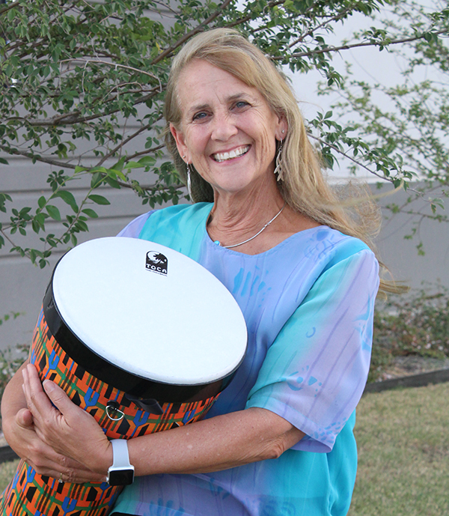Toca Percussion is pleased to announce a teaching and product arrangement with Mary Knysh. Mary is the founder of Rhythmic Connections, an innovative company advancing education, health, community building, and creative development through drum circles and music improvisation, **and**has traveled the world for over 35 years inspiring participants to tap into healing and human potential through the transformative power of music. Mary is also a professional musician, recording artist, and published author who works with people of all ages. A sought-after facilitator, trainer, and Orff Schulwerk clinician Mary has long been an endorser of Rhythm Band Instruments, the parent company of Toca Percussion.

Since the release of the Toca Freestyle II line of drums, Mary has increasingly used these instruments as part of her repertoire. And with those Toca products as a base, she has created a curriculum course designed for music educators, music therapists and drum circle facilitators to develop and practically apply methods, techniques and practices for leading and engaging students, Pre-K to Grade 5 in creative music performance circles that emphasize improvisation, responsive musicianship, social emotional awareness, student leadership, and community building using body, percussion, voice, drums and small percussion.

Central to this course is a World Drumming Kit anchored by Freestyle II Nesting Djembes and Tom-Toms, Toca’s game changing Flex Drums, Egg Shakers and an assortment pitched tubes from Toca’s sister company, Boomwhackers.

“I am absolutely enthralled by Toca’s line of nesting and pre-tuned world percussion drums,” says Mary. “As an educator, I couldn’t want for more, they are light-weight, super easy to transport, incredibly versatile and, best of all, they sound amazing! These are not just kids’ drums, these are drums for everyone!”

[tocapercussion.com](http://www.tocapercussion.com)