**Contact:** Rick Taylor

RBI Music

**Tel:** 817-335-2561 x105

**Email:** [rick.taylor@rbimusic.com](mailto:rick.taylor@rbimusic.com)

**Silvertone® Guitars Launches New 1444 Reissue Bass!**

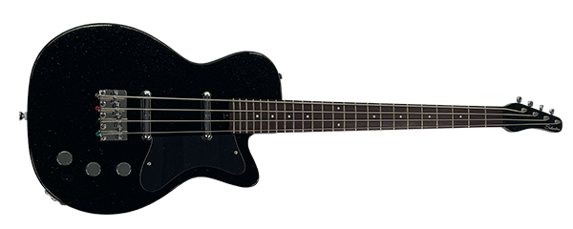Silvertone Guitars, manufacturer of wholly unique and widely affordable electric and acoustic guitars since 1940 is pleased to announce the release of the 1444 Reissued Bass. The original Silvertone 1444 basswas the very first 4-string electric bass offered by Sears back in 1959. It featured a “U” style body with a rounded neck cutaway and aluminum cavity cover. This model 1444 held down the bottom end for Silvertone for 7 strong years, ending production in 1966.

The new Silvertone 1444 reissue bass is a modified version of the original Silvertone 1444. It has been redesigned for the modern bassist and can easily produce vintage and modern tones. The Reissue 1444 features a 24 fret 30” short scale rock maple neck with rosewood fingerboard and a solid mahogany body. We modified the bass by adding a bridge position lipstick pickup for added versatility, and a fully adjustable bridge.

The electronics are two Silvertone lipstick pickups with Volume, Volume, and Tone controls. Unlike the original 1444, the new reissue also features a fully adjustable dual expanding truss rod.  
  
The Silvertone 1444 will be available in three colors: Black Silver Flake (BSF), Copper Metallic (CM), and Silverburst (SVB).

“We are so excited to be adding to the Silvertone line of products”, says Silvertone Product Manager, Rick Taylor. “This is just the start, and we have a lot of plans on how to expand this iconic and deeply rich brand!”

Visit the new Silvertone site at [**SilvertoneGuitars.com**](https://silvertoneguitars.com/)

Silvertone Guitars is a wholly owned brand of RBimusic.