**Contact:** Rick Taylor **For Immediate Release**

RBI Music

**Tel:** 817-335-2561 x105

**Email:** [rick.taylor@rbimusic.com](mailto:rick.taylor@rbimusic.com)

**Silvertone® Guitars Launches New Website – silvertoneguitars.com!**

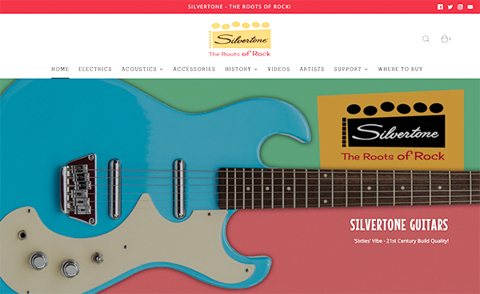Silvertone Guitars, manufacturer of wholly unique and widely affordable electric and acoustic guitars since 1940 is thrilled to announce the launch of their new website. With the explosion of guitars sales throughout the world it was time to make the website match the times.

The new site prioritizes ease of navigation with simple dropdown menus that let the user find specific guitars with ease; accurate and complete product info on every product page that includes feature close-ups as well as demonstration videos; detailed artist information; a robust dealer finder, and incredibly fast page load times. Silvertone has become known for its retro looks combined with the latest technology and specs, and the new site matches that ethos. It has a retro chic aesthetic while still providing everything you need to rock and roll! These Roots Run Deep!

“Our old site was super cool too”, says Vintage Product Manager, Rick Taylor, “but this new version takes it to a whole new level. On both the desktop and mobile platforms, the user experience is simply amazing. The speed of the site, the ease with which one can find exactly what they are looking for, and video demos for every single guitar at your fingertips really makes the site special.”

Visit the new Silvertone site at [**SilvertoneGuitars.com**](https://silvertoneguitars.com/)

Silvertone Guitars is a wholly owned brand of RBimusic.