**Contact:** Rick Taylor

RBI Music

**Tel:** 817-335-2561 x105

**Email:** [rick.taylor@rbimusic.com](mailto:rick.taylor@rbimusic.com)

**Silvertone® Guitars 1303 “Sixties” Reissue Solid Body Electric Now in Copper Top!**

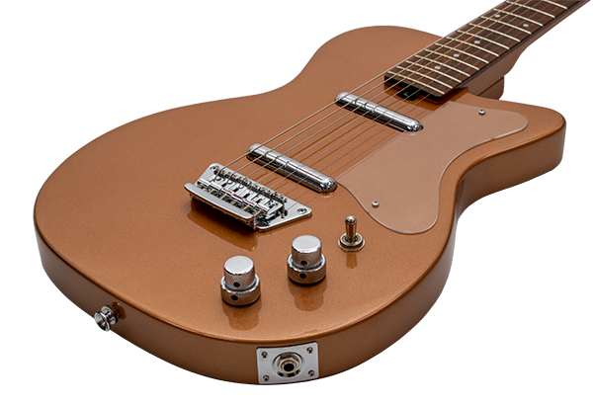Silvertone Guitars, manufacturer of wholly unique and widely affordable electric and acoustic guitars since 1940 is pleased to announce the release of the 1303CM “Sixties” Reissue Solid Body Guitar in a stunning new color; Copper Metallic.

Silvertone introduced one of the earliest solid body guitars in the fall of 1954. That early model evolved into the 1303 in 1958. The Reissue 1303 has all the vibe and twang of the original with some significant upgrades. The thru-body bridge provides great attack and hefty tone while giving you all the modern adjustment options every player wants. They also paid special attention to the neck profile, improving it with a modern C-shape, as well as coupling it to the body with a newly engineered neck joint system for longer sustaining notes. And now, one of the world’s most enduring and beloved guitars is getting the copper top treatment. Lovingly adorned with a metallic copper finish, this new model is sure to attract attention in stores and on stages.

“Silvertone released the first copper finish 1301 guitar in 1957,” says Silvertone Product Manager, Rick Taylor. “We’re excited for players to see the return of this beautiful color on our popular 1303 model!”

Visit the new Silvertone site at [**SilvertoneGuitars.com**](https://silvertoneguitars.com/)

Silvertone Guitars is a wholly owned brand of RBimusic.