**Contact:** Rick Taylor

RBI Music

**Tel:** 817-335-2561 x105

**Email:** [rick.taylor@rbimusic.com](mailto:rick.taylor@rbimusic.com)

**Silvertone® Guitars 633 Jumbo Acoustic/Electric Baritone – That Deep Sound Just Got Deeper!**

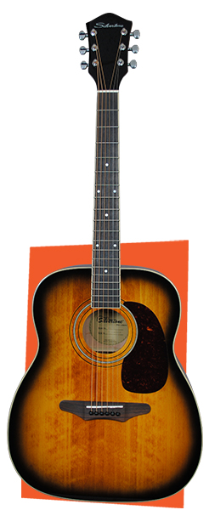Silvertone Guitars, manufacturer of wholly unique and widely affordable electric and acoustic guitars since 1940 is pleased to announce the release of the new Natural (633EB N) and American Vintage Sunburst (633EB AVS) “Baritone” Jumbo Acoustic/Electric guitars. The original 633 was brought to market in 1965 and was the first Dreadnought size guitar to be produced by Sears.

This new 633EB “Baritone” guitar is Based on the existing 633 Jumbo Acoustic model and features a solid Engelmann Spruce top and Mahogany back and sides for a well-balanced, articulate and deep sound. The unique Silvertone jumbo dreadnought body shape is perfect for baritone tuning. The lowest notes speak with authority and growl. The 633EB features D'Addario baritone strings tuned B-E-A-D-F#-B and comes complete with a full featured Fishman® Clearwave60 preamp with built in tuner.

“This baritone acoustic is the perfect addition to any home studio,”

says Silvertone Product Manager, Rick Taylor. “The unique tone will add some real spice to your recordings!”

Visit Silvertone at [**SilvertoneGuitars.com**](https://silvertoneguitars.com/)

Silvertone Guitars is a wholly owned brand of RBimusic.