**Embargoed Until September 1, 2022**

**Contact:** Rick Taylor

RBI Music

**Tel:** 817-335-2561 x105

**Email:** [rick.taylor@rbimusic.com](mailto:rick.taylor@rbimusic.com)

**Silvertone® Guitars and Jackson Audio Team Up for Classic 1484 Twin Twelve™ Pedal**

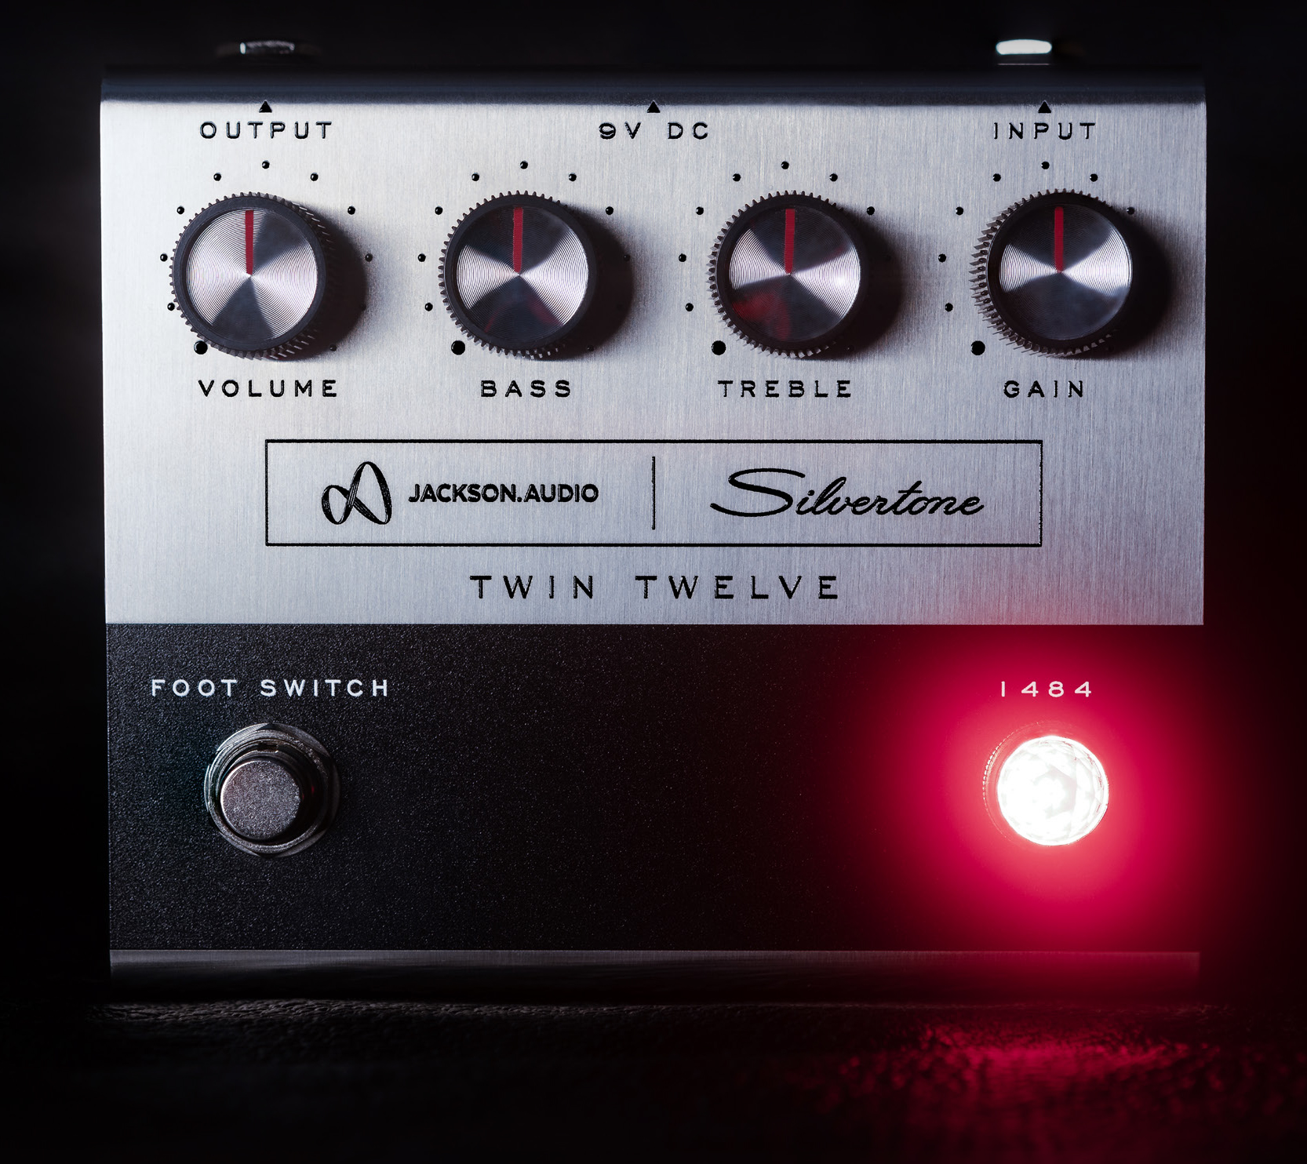Silvertone Guitars, manufacturer of wholly unique and widely affordable electric and acoustic guitars since 1940, and Jackson Audio, one of the most innovative and customer-oriented guitar electronics companies operating today, are thrilled to announce the release of an all new Silvertone® guitar effects pedal that beautifully recreates the renown Silvertone “Twin Twelve™” model 1484 guitar amp, both in sound and looks.

The Twin Twelve was offered from 1963 to 1967 and became the most coveted of all the Silvertone amplifiers. The unique sound of this amplifier proudly powers the tones of many of today’s best rock icons such as Jack White, Dave Grohl, Beck, Billie Joe Armstrong (Green Day), Dan Auerbach (The Black Keys) and many more.

This new pedal was meticulously designed and engineered from scratch to evoke the look of the famous 1484 amp and to exactly replicate its tone. It can be used as a studio grade preamp, booster, EQ or overdrive depending on how the controls are set.

“The people at Jackson Audio are top notch,” says Brad Kirkpatrick, President of RBI Music, parent company of Silvertone Guitars, “and the way they have been able to recreate that classic 1484 sound is nothing short of amazing.”

Brad Jackson, President and CDO of Jackson Audio, adds “We are so pleased to have been able to collaborate with Silvertone on this unique and special project. The end result has been just fantastic! If you play the two side by side, you can’t tell which is the original amp and which is the new pedal.”

Silvertone Product Manager, Rick Taylor, says “I am so excited about this pedal. The sound is stunning, and the look is as cool as it gets! This pedal is another vital step in the revival of the iconic Silvertone name. And it’s just the start. We have more new products and accessories in the pipeline.”

Price: $249.00  
Available to Consumers: September 1, 2022

Visit Silvertone at [**SilvertoneGuitars.com**](https://silvertoneguitars.com/)

Silvertone Guitars is a wholly owned brand of RBimusic.