**Contact:** Jim Rockwell **FOR IMMEDIATE RELEASE**

RBI Music

**Tel:** 201-247-7225

**Email:** marketing@rbimusic.com

**RBI Music Names Eric Sands as National Sales Manager**

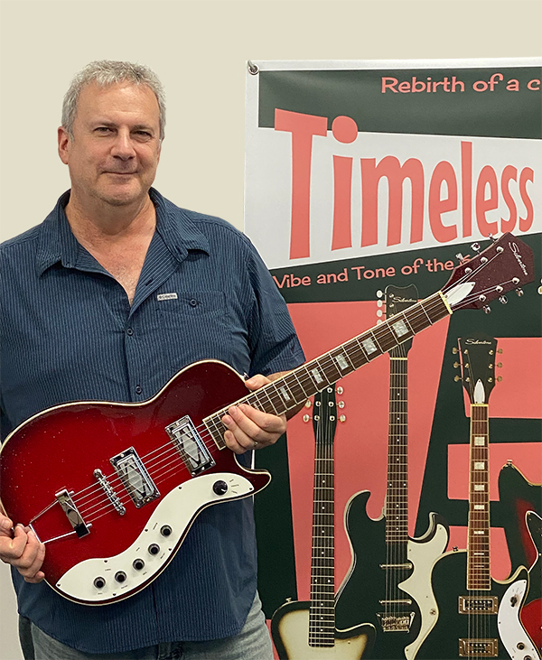July, 2022 – Rhythm Band Instruments, LLC, has announced that

Eric Sands has been named National Sales Manager for RBI Music. Eric will be responsible for domestic sales and sales administration for all RBI Music brands including Toca, Silvertone, Grover Pro, Boomwhackers, Vintage, Aulos and Big Joe.

Previously, Eric worked as Sales Manager - Americas for Positive Grid, National Sales Manager for Orange Amplifiers and District Sales Manager for KORG USA. “Eric’s experience working with dealers, key accounts and rep firms are a perfect fit for us. He will help us to move forward, build great relationships and grow the market for our brands,” said Brad Kirkpatrick, President, and CEO of RBI Music.

Eric added, “I look forward to working with the team and great brands at RBI Music while providing excellent support for our dealer partners”.

[rbimusic.com](https://rbimusic.com/)