**Contact:** Jim Rockwell **FOR IMMEDIATE RELEASE**

**RBI Music**

**Tel:** 201-247-7224

**Email:** marketing@rbimusic.com

**Grover Pro Percussion Timpani Road Case - Organize, Store, and Transport Your Timpani in the Safest Manner Possible!**

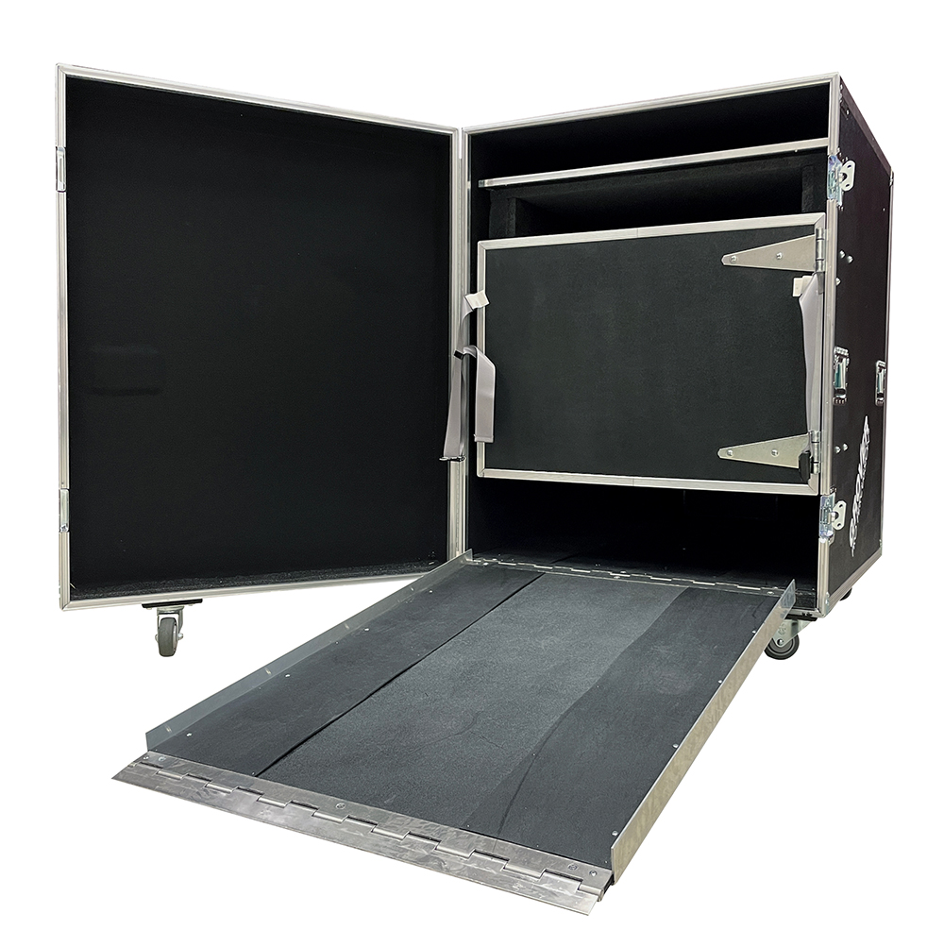Grover Pro Percussion, world leader in high quality percussion products since 1980, has introduced the Grover Pro Percussion Timpani Road Case. It is perfect for pros, orchestras, schools, bands, percussion groups, and anyone else looking to keep timpani safe and secure during transport.

The Timpani Road Case rests on large 4-inch industrial casters that facilitate easy transport. All the wheels have locking mechanisms to ensure stability when stationary. Timpani will be safely protected even when the Timpani Road Case is transported over rough terrain. The Grover Pro Percussion Timpani Road Case is constructed to provide years of trouble-free service in band rooms, concert halls, percussion studios, stadiums, and even on the field!

Features:

* Available in 4 sizes:  32/31” –  29/28” –  26/25” –  24/23”
* Fits all brands of timpani
* Heavy duty ATA construction
* Internal ramp aids in loading
* Two stage foam surround padding
* Spare head compartment
* Timpani rear wheel access panel
* Heavy duty locking casters

rbimusic.com

groverpro.com