**Contact:** Jim Rockwell **FOR IMMEDIATE RELEASE**

**RBI Music**

**Tel:** 201-247-7224

**Email:** marketing@rbimusic.com

**Grover Pro Percussion Temple Block Case – The Perfect Way to Protect and Transport Your Temple Blocks!**

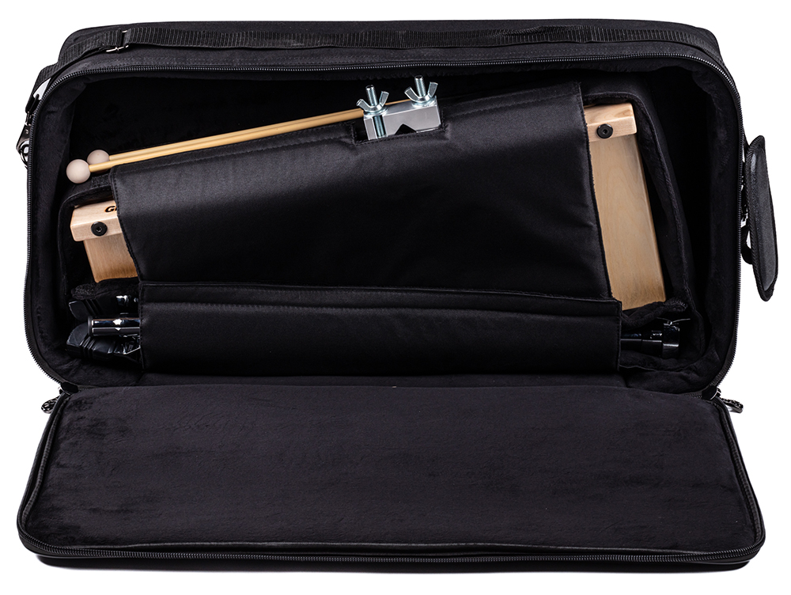Grover Pro Percussion, world leader in high quality percussion products since 1980, has introduced the Grover Pro Percussion Temple Block Case. It was purpose-designed to securely and conveniently transport both our TPB-X 5-Piece Baltic birch “Open Tone” temple blocks w/ mounting clamp, and our adjustable-height, double-braced stand, with room for more, including mallets or other small gear.

Whether in storage or while being transported across the globe, tjis case will shield your blocks from accidental damage. Manufactured from a synthetic material that is “tour-tough”, this padded case is also water resistant. An adjustable Velcro flap secures the blocks in place to ensure that they are securely protected during transport. The robust handle and an adjustable shoulder strap are features that help make the moving of your temple blocks and stand both quick and easy. *Just throw in your music and you’re ready to leave for the gig!*

groverpro.com

rbimusic.com