**Contact:** Jim Rockwell **FOR IMMEDIATE RELEASE**

**RBI Music**

**Tel:** 201-247-7224

**Email:** marketing@rbimusic.com

**Grover Pro Announces Doritos® “Triangle” as best Commercial of the Big Game**

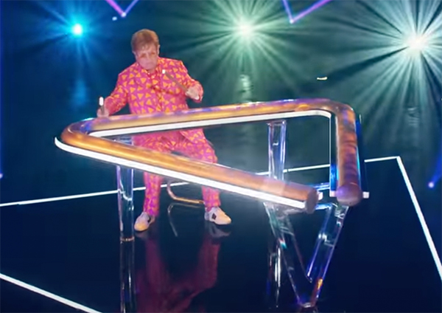Grover Pro Percussion, Found In the World’s Finest Concert Halls™, announced that the Doritos “Triangle” commercial is the winner of its first annual Best Commercial in the Big Game of the Year Award. The award comes with no trophy and no cash prize.

“The creativity and execution of that spot was phenomenal,” gushed Neil Grover, Founder of Grover Pro Percussion. “I nearly jumped out of my chair when it come on the screen. And its well past time that the triangle received its due. Of course, the triangle should have its own awards show,” Grover noted, tongue-in-cheek.

“In all seriousness, my hat goes off to the Doritos creative team and the impressive roster of major artists, including Jack Harlowe, Missy Elliott and Elton John among others, who lent their talents to creating this terrific spot. I only wish each of them were endorsers of Grover Pro Percussion products but, alas, at this time, Grover Pro Percussion has no affiliation with Doritos, The Pepsi Cola Company, the Big Game or any of the artists featured in the advertisement.”

groverpro.com

rbimusic.com