**Contact:** Jim Rockwell **FOR IMMEDIATE RELEASE**

RBI Music

**Tel:** 201-247-7224

**Email:** marketing@rbimusic.com

**Toca Synergy Deluxe Wood Congas – Entry Level Price – And Editors Choice Winner!**

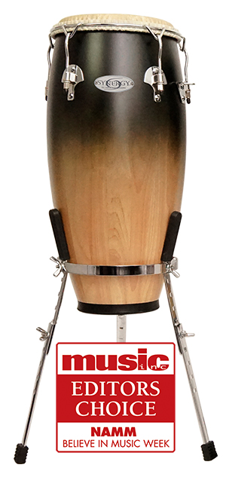Toca Percussion won its fourth Editors Choice award in as many years with their Synergy Deluxe Wood Congas. Taking entry-level percussion to new heights, Toca Percussion announced the arrival of their new Synergy™ Deluxe line of congas at Believe in Music Week this past January. And with that dealers, consumers and the editors at Music, Inc. took immediate notice. Building on Toca’s hugely popular Synergy line of drums, Synergy Deluxe adds superior upgrades in a thrifty package. Enhancements include REMO® Tucked Fiberskyn® heads, low-contact hoops, an elegant satin fade finish, chrome hardware and included adjustable chrome basket stands.

“The upgraded heads alone are worth the difference in cost, and that’s just the beginning!” notes Lane Davy, RBI EVP of Sales and Marketing. “Add in the nicer hardware and finish and these drums are a great value.”

Like the standard Synergy congas, Synergy Deluxe drums are 28 inches tall, made from 2-ply Asian Oak staves and sold as a set of 10” and 11” drums. However, with Synergy Deluxe, percussionists have the option to add a matching 12” Tumba. Synergy Deluxe models are available in several colors including Coffee Fade, Purple Fade, Wine Fade and Natural. All drums feature a satin finish.

Of the win, Davy added, “we are so excited about this new line of congas, and to win the Editors Choice award too, that reinforces that we are making the right decisions when it comes to product development. We take pride in every product we make, but to win awards as well is another level of satisfaction of a job well done.”

tocapercussion.com

rbimusic.com