**Contact:** Jim Rockwell **FOR IMMEDIATE RELEASE**

RBI Music

**Tel:** 201-247-7224

**Email:** [marketing@rbimusic.com](mailto:marketing@rbimusic.com)

**Toca Wins Best In Show Award at Believe in Music Event for the Kickboxx Suitcase Drumset!**

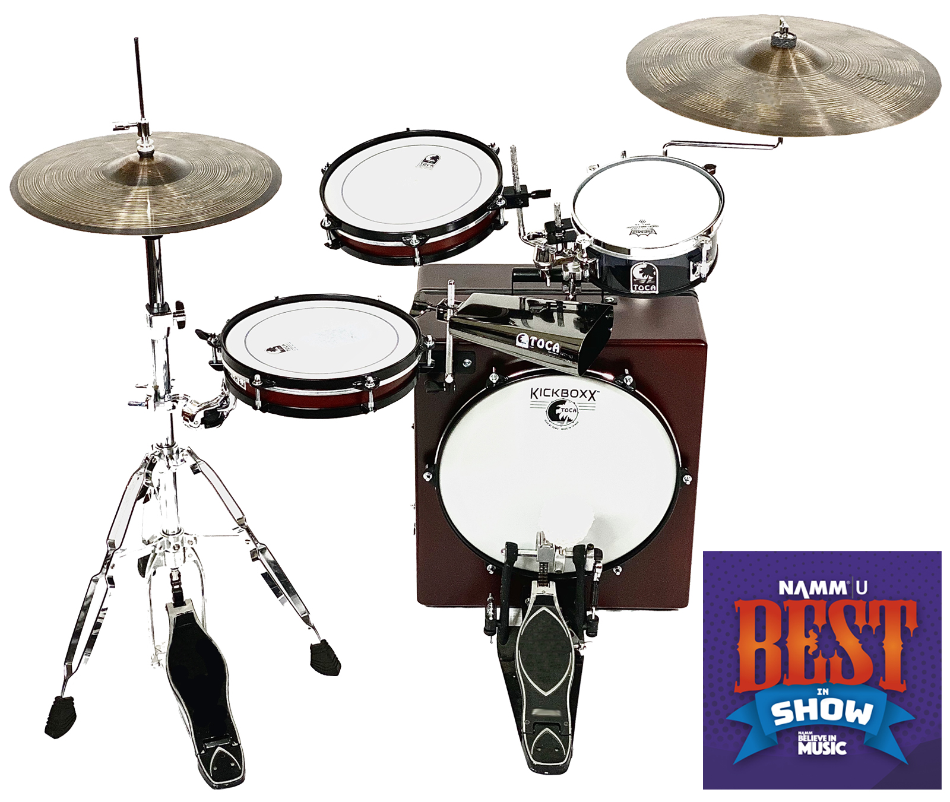Toca Percussion won its 2nd Best in Show award in four years with The Kickboxx™ Suitcase Drumset in the coveted “Gotta Stock It” category. This amazing “little” product with a big sound, sets a new standard in drum kit portability and convenience. Standing a mere 22 inches tall, the entire set-up fits inside the box with room left for a kick pedal. The Kickboxx itself features a 14” Remo P3 head, plate for attaching a standard bass drum pedal and is ported in the back. There are adjustable mounting posts installed front and back for attaching the tom, snare and other accessories. The posts telescope in and out from the box and can be rotated up for playing or down for storage. Secured with 2 sturdy latches, the hinged box swings open to allow the snare and tom to be secured to the post on the inside of the box. A fixed handle doubles as a rack tube for attaching additional drums and accessories.

The 10” tom and snare are based on Toca’s popular frame drums and feature two thick plys of Asian Oak topped with coated Remo heads. The snare drum features an adjustable, fan-style snare complete with throw-off.

**Shane Kinney**, **Owner – Drum Center of Portsmouth in North Hampton, NH**, who picked The Kickboxx for the win said “I absolutely love this thing, I can’t get enough of it! For the last 15 years we’ve seen this trend of people wanting compact drum sets so they can play their smaller gigs. The industry has responded to that… but this is incredibly compact. And it actually sounds good! It comes at the perfect time.” The Kickboxx is “a little portable drumset. It’s got a really cool sound. It’s got a really great, attractive price, and it’s expandable too! You really can’t lose with this one, I just love it!”

According to Lane Davy, RBI EVP of Sales and Marketing, the main goal was to produce a truly functional musical instrument in an ultracompact form. “The Kickboxx is a musical instrument first. We started by designing drums that sounded good and then built the concept from there,” he notes. “What we didn’t want was a gimmick with no substance.” Perfect for tight performance areas, busking, tiny homes or drummers with small cars, the Kickboxx takes drumset portability and convenience to a whole new level.

[tocapercussion.com](http://www.tocapercussion.com)