**Contact:** Jim Rockwell **FOR IMMEDIATE RELEASE**

RBI Music

**Tel:** 201-247-7224

**Email:** [marketing@rhythmband.com](mailto:marketing@rhythmband.com)

**Toca Adds New Timbale to its Line of Custom Deluxe Percussion Instruments!**

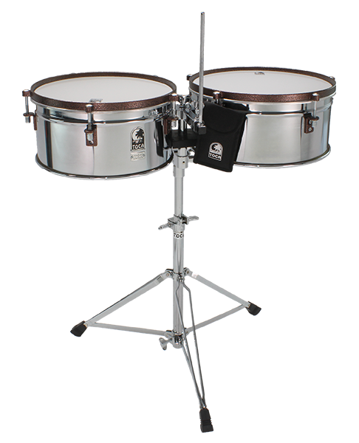For the past few years, the Toca Percussion line of Custom Deluxe bongos and congas has been lighting up the hand drumming world with its best-in-class quality, sound and playability combined with a choice of show-stopping color choices. Now, Toca has rounded out the line with a set of timbales, completing the traditional triumvirate of bongos, congas and timbales one has come to expect.

These timbales, with their 14” and 15” chrome plated steel shells produce a classic cascara as well as catch the spots and light up the stage. On top of those shells are Powder Coated Antique Bronze finished rims, that were specifically designed to hold up through thousands of rim shots and always look as great as they sound. And the tuning bolts have been lowered below the rim to reduce interference, making more of the drum accessible to rim shots, thus improving speed when moving from one drum to the other. There’s a fully adjustable cowbell mount and mounting bracket above the drums that allows the player to add cowbells and blocks as needed (but not included). One major frustration with many Timbales sets has been eliminated too! The wing nut used to tighten the mounting bracket has been placed below the rims so there’s no cross-sticking interference. And every good set of Timbales deserves a heavy duty, fully adjustable tripod stand. That’s exactly what Toca has provided for this set.

“At Toca, we understand that instruments like these, that literally take a beating, have to match the three demands of live performance.” says Lane Davy, Executive Vice President of Sales and Marketing at RBI, “They need to look good on stage. They need to sound amazing. And they need to stand up to the rigors of road life and being played on stage!” These new Custom Deluxe Timbales pass this test with flying colors… along with some Antique Bronze.

[tocapercussion.com](http://www.tocapercussion.com)