**Contact:** Jim Rockwell **FOR IMMEDIATE RELEASE**

RBI Music

**Tel:** 201-247-7224

**Email:** [marketing@rbimusic.com](mailto:marketing@rbimusic.com)

**Trio of Drummers, Cody Leppo, Jake Sommers and Robin Diaz Sign with Toca Percussion!**

Toca Percussion announces the signing of three drummers playing across two distinct genres to Toca Percussion endorser contracts.

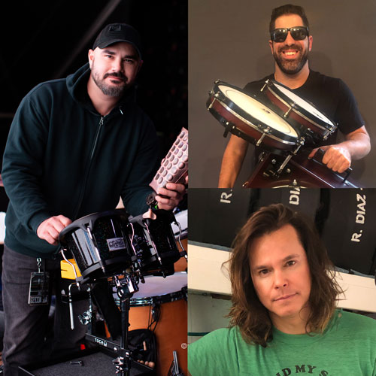Cody Leppo is a highly sought-after Nashville Based, Producer/Engineer, Session/Live Performance drummer. He has performed and recorded with artists from all around the world.  
He has the privilege to have played with Hal Ketchum, John Rich, Keith Anderson, Johnny Hiland Band, Jacob Underwood (OTOWN), Erin James & many more... Cody currently plays for country artist Jamey Johnson and says, “I am honored to be a part of the Toca Percussion Family. Whatever I might need to get the job done, they have it. Toca is the best!”

Toca’s other country drummer signing is Jake Sommers, a Nashville drummer who tours live with Luke Combs. Originally from New York Jake always knew he was going to be a drummer, so he attended The University of the Arts in Philadelphia. After moving to Tennessee in 2013 he began performing with a variety of artists. "It’s a great honor to join the Toca Family!” says Jake, “They make wonderful products that can be put to the test of live or studio work. Whatever your percussion needs may be, Toca has it!"

Clockwise from L: Cody Leppo; Jake Sommers; Robin Diaz

The third drummer to recently join Toca’s artist ranks is Robin Diaz. As a young drummer he attended [Musicians Institute](http://mi.edu/)in Hollywood California, under the PIT program. It was there that he studied with top session drummers and teachers Ray Luzier, Joe Pocaro, Ralph Humphries, and Fred Dinkens among others. After graduating MI Robin began playing, recording and touring with a truly impressive list of artists that would make any drummer jealous. Robin hooked up with hard rock band Candlebox in 2017, and appears on their recent live album. Although Robin is a recent Toca signing, he indicated that, “Ive been using Toca Percussion instruments for pretty much my entire professional career whether it’s been on records or touring and now I’m proud to be part of the family officially!”

“I have known Cody Leppo for a number of years. It was an honor for me to ask my friend if he wanted to join the Toca Percussion family” says Artist Relations Manager, Mark Petrocelli. “In turn Cody introduced us to his friend Jake Sommers and Jake brought Robin Diaz to the family. That’s the way it’s supposed to work, right? We are excited to expand our drumset roster of players and look forward to seeing them incorporate Toca Percussion accessories into their rigs.”

[tocapercussion.com](http://www.tocapercussion.com)