**Contact:** Jim Rockwell **For Immediate Release**

RBI Music

**Tel:** 817-335-2561 x105

**Email:** [marketing@rbimusic.com](mailto:marketing@rbimusic.com)

**RBI Music Announce Launch of New RhythmBand.com Website!**

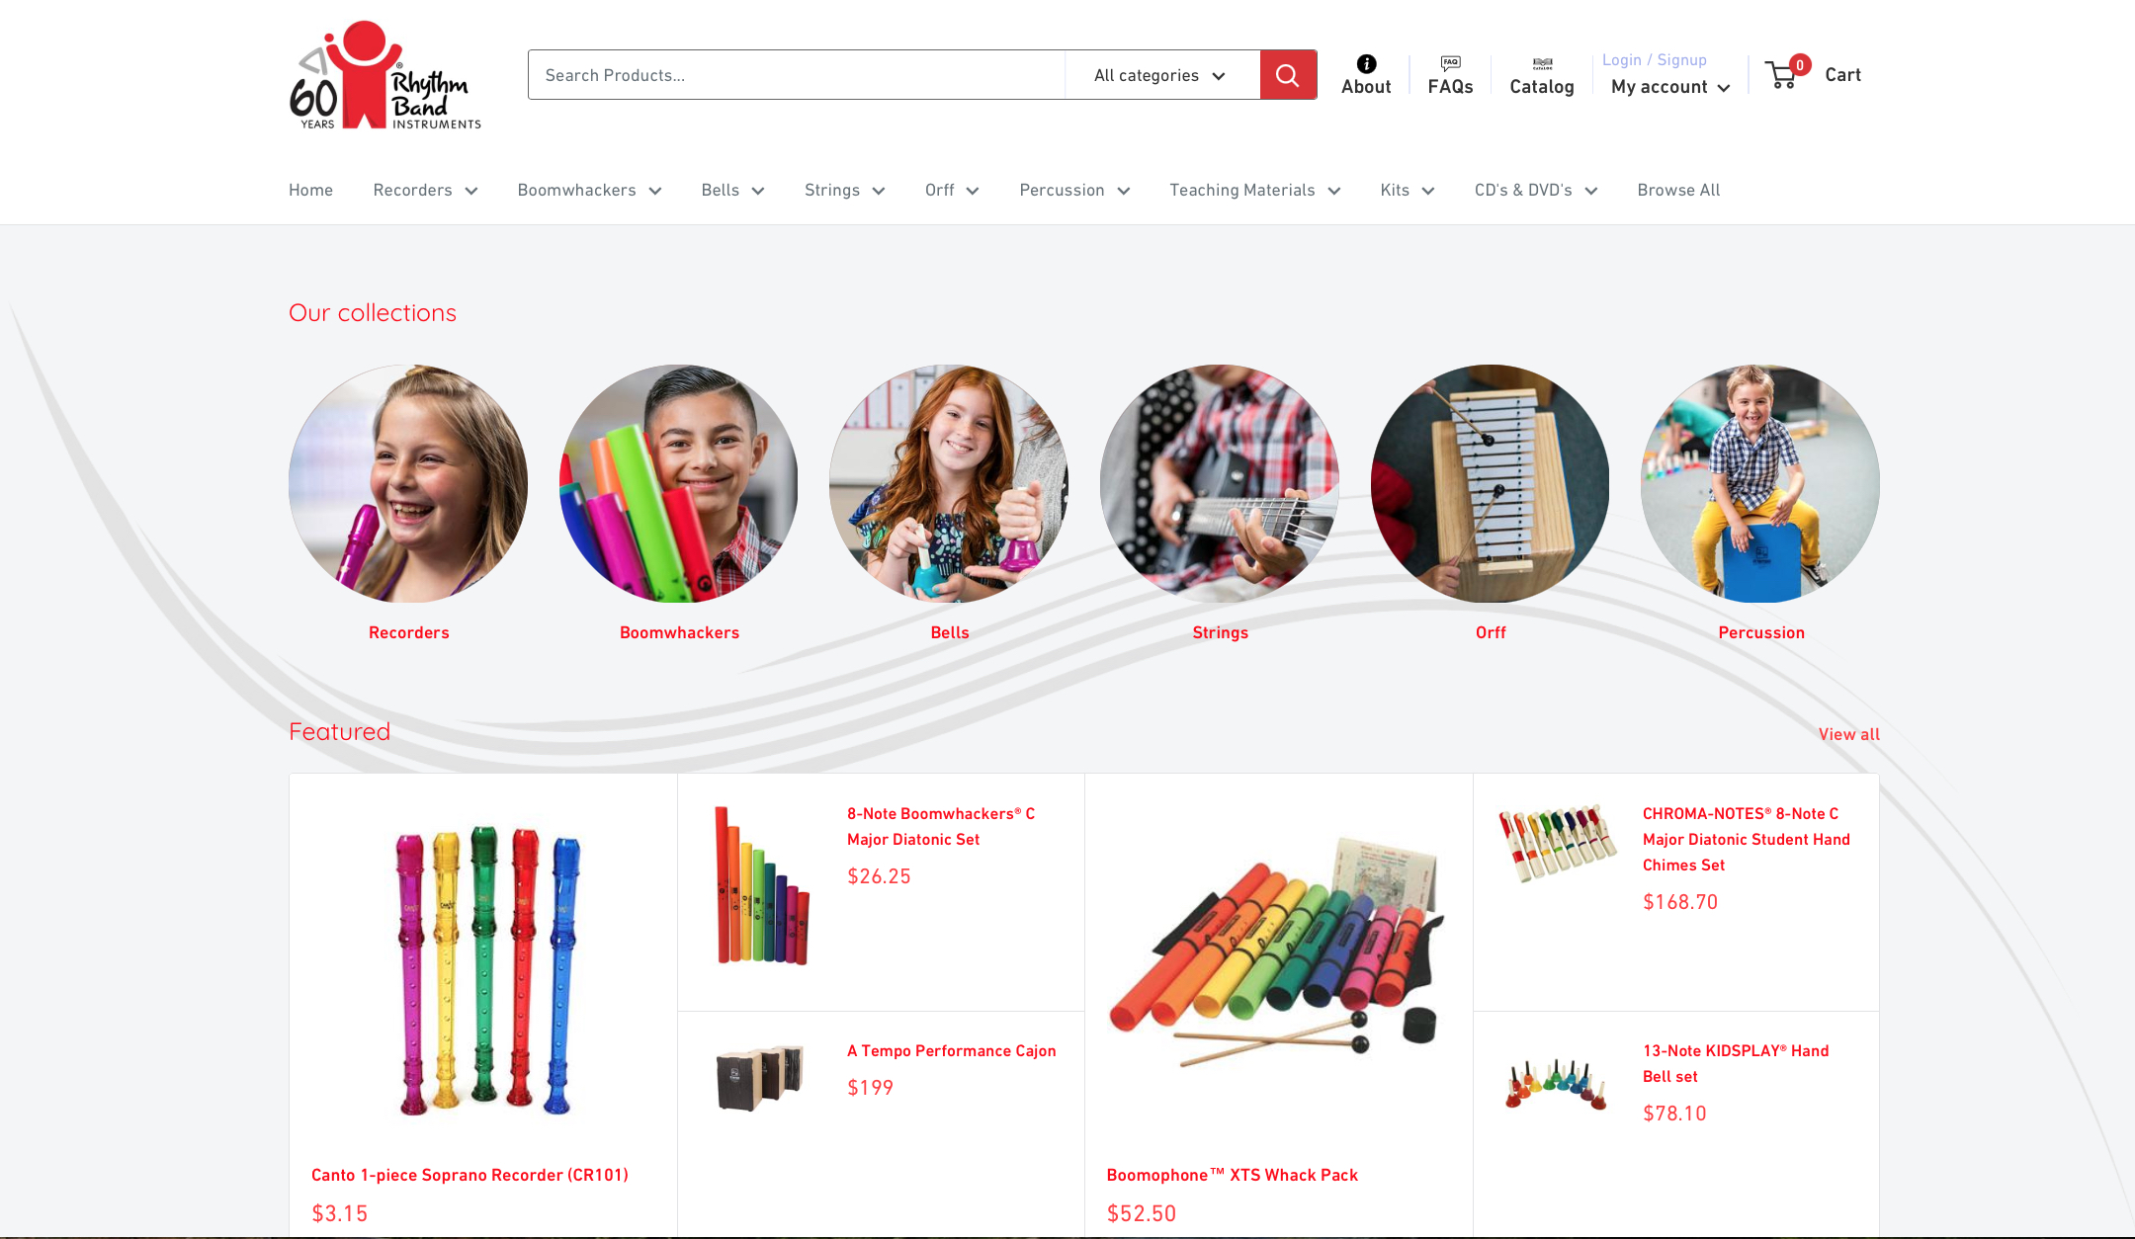

RBI Music, owner of Toca, Boomwhackers, Grover Pro Percussion and distributors of Vintage Guitars, Silvertone Guitars and A Tempo percussion are excited to announce their new Rhythmband.com website! Rhythm Band Instruments has been in business since 1961 and has launched the new site as part of its 60th Anniversary activities. The Rhythm Band part of RBI Music focuses on early and school music education.

The new website has a number of exciting new features, and finding products has never been easier. Simple drop-down menus and perfectly curated filters let the user dig down and find exactly what they are looking for in a jiff! Once they find that item, there are plenty of product images that you can zoom into, and the descriptions are detailed, so customers will know exactly what will be coming in the box.

Updating their sites to match with the times has been a mantra for RBI this year, and rhythmband.com site is no exception. On both the desktop and mobile platforms, the user experience is simply amazing. The user can easily add products to their cart or click the "Buy it now" button to purchase immediately. And of course, they can shop with the knowledge that their information is processed securely. RBI doesn't see, store, or have the ability to access any credit card info.

Lane Davy, Executive Vice President of Sales Marketing, is quite excited about a particular feature of the new site. “Do you ever get frustrated that your shipping cost is a mystery until you go to check out? On the new rhythmband.com site we have a nifty little feature that lets the user figure that out right on the product page, before you even add the item to your cart! And it’s dynamic”, he says. “Change the quantity or shipping location and the shipping cost updates immediately. Sometimes it’s these little features that can add so much satisfaction to a user’s experience!”

Visit the new Rhythm Band Instruments site at [RhythmBand.com](https://www.rhythmband.com/)