**Contact:** Jim Rockwell **FOR IMMEDIATE RELEASE**

RBI Music

**Tel:** 201-247-7225

**Email:** marketing@rbimusic.com

**RBI Music Acquires Silvertone® Brand**

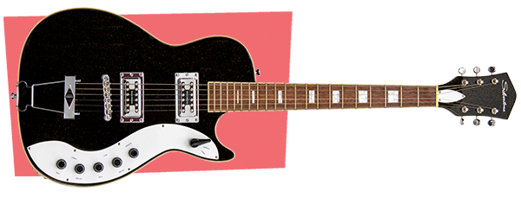December, 2021 – Rhythm Band Instruments, LLC, announced today the acquisition of all assets, including all intellectual property, related to the Silvertone brand from the Samick Music Corporation. The historic Silvertone brand was created over a century ago by Sears, Roebuck & Company as its “house” brand for consumer electronics and musical instruments, most famously guitars and amplifiers. The brand has been owned by Samick Music since 2001.

“Just over a year ago we announced our exclusive distribution agreement for the Silvertone brand,” said Brad Kirkpatrick, President of Rhythm Band. “Clearly, that has gone really well – better than our initial expectations. So, we approached Samick Music with an attractive proposal to acquire the brand outright and, we are pleased to announce, they agreed, and we closed that transaction effective September 30.” We are excited to continue the excellent efforts undertaken by Samick to reestablish the Silvertone brand and look forward to doing our own work in taking this iconic brand forward.”

Rhythm Band Instruments has been distributing musical instruments and music education material from Fort Worth, Texas for over 60 years. In 2009, the company acquired the Boomwhackers**®** brand of tuned musical tubes. In 2016 it bought the Toca Percussion® brand of hand percussion instruments, and Grover Pro Percussion**®** joined the company’s stable of world-class brands in 2019. Rhythm Band also exclusively distributes a number of other brands, including Big Joe Stompbox**®**, Chromanotes**®**, Kidsplay**®** and ChromAharP**®** world-wide, as well as Vintage**®** guitars, in the U.S. only, via RBI Music.

“We could not be more thrilled that we now own the Silvertone brand,” noted Rick Taylor, Product Manager for RBI Music. “The opportunity is immense for RBI and this iconic American guitar brand. We’ve got plans for some minor tweaks to the existing lineup, several new electrics, more colors, accessories – all of it. Watch this space for further developments. We can’t wait for NAMM 2022. Guitarists around the globe are in for a treat!”

[rbimusic.com](https://rbimusic.com/)

[silvertoneclassic.com](https://www.silvertoneclassic.com/)