**Contact:** Jim Rockwell **FOR IMMEDIATE RELEASE**

**RBI Music**

**Tel:** 201-247-7224

**Email:** marketing@rbimusic.com

**Grover Pro Percussion Footrest - You’ll Wonder How You Ever Managed Without It!**

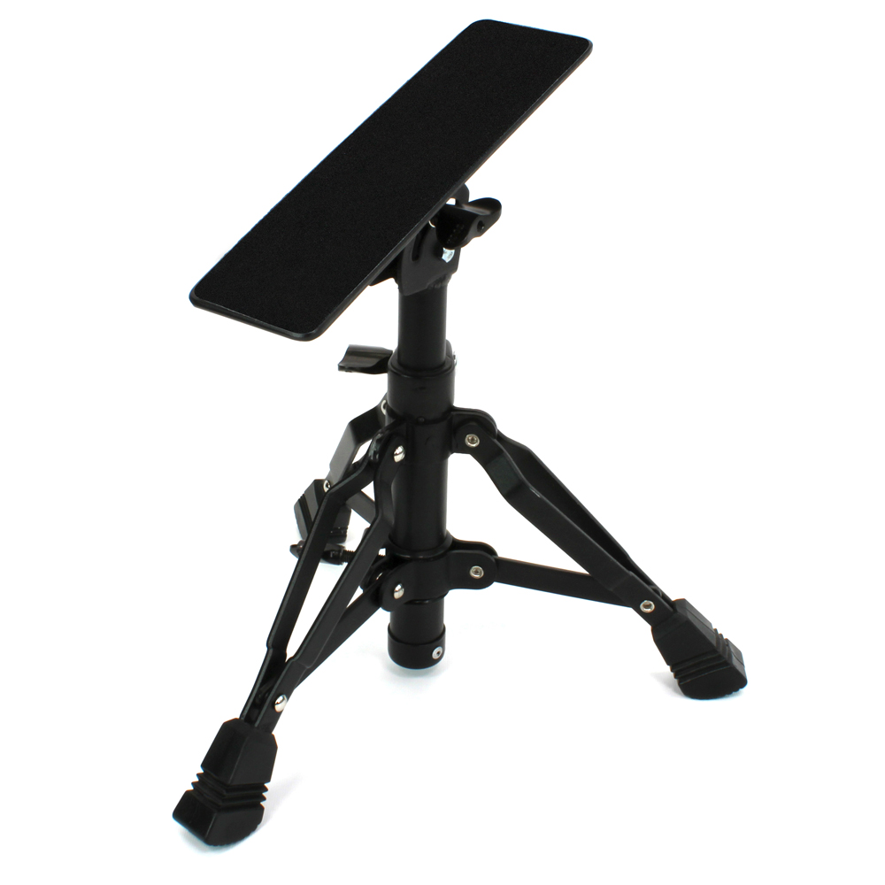Grover Pro Percussion, world leader in high quality percussion products since 1980, has introduced an innovative solution for percussionists of all skill levels. Designed in collaboration with professional percussionist Kirk Gay, the new Grover Pro Percussion Footrest is a versatile performance tool which will prove indispensable for the playing of concert bass drum, tambourine, castanets, and other percussive accessories.

When placed adjacent to a concert bass drum the Percussion Footrest functions as a stable platform used to support a raised knee, thereby facilitating easy bass drum muffling. This adjustable foot stand will also prove indispensable when the concert repertoire demands that percussionists use a knee as a striking surface when executing fast tambourine or castanets passages.

Features include:

* Height adjustment
* Footboard angle adjustment
* Non-slip footboard surface
* Easily folds for transport/storage

“When Kirk and I initially came up with the idea of this product I was surprised that there wasn’t something similar in the market already,” said Grover Pro founder, Neil Grover. “We think it’s definitely one of those ‘why didn’t I think of that’ type of products, and once percussionists try the Percussion Footrest they’ll wonder how they ever managed without it.”

rbimusic.com

groverpro.com