**Contact:** Jim Rockwell **FOR IMMEDIATE RELEASE**

RBI Music

**Tel:** 201-247-7224

**Email:** [marketing@rbimusic.com](mailto:marketing@rbimusic.com)

**Toca Introduces New Pandeiro – Expanding Its Line of World Percussion Frame Drums**

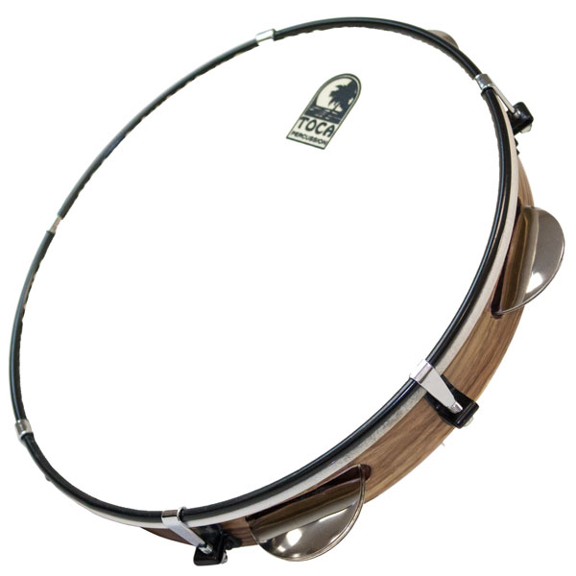Toca announces the addition of the quintessential Brazilian percussion instrument to its lineup. Toca Pandeiros, available in 12” and 10” sizes, are tunable and feature synthetic heads for a stable pitch. The steel plantinellas are cupped creating a crisp, dry tone with a fast decay.

The new Toca Pandeiro is ideal for playing traditional Brazilian sambas and chorinhos as well as modern rhythms like funk and samba reggae.  
  
The Toca Pandeiro is lightweight and features stainless steel jingles that fit perfectly with today's modern playing techniques. It is also part of Toca’s ever increasing line of instruments from around the globe, joining in with its Middle Eastern drums like the Riq and Mazar and the more traditional frame drums and tambourines.   
  
Toca Pandeiros are equipped with a single row of five triple-set chrome plated jingles producing crisp sounds and enable fast articulated beats allowing the low tones of the 10” head with 5 sets of jingles and the 12” head with 6 jingles to resonate freely. A tuning wrench and carry bag are included.

“These pandeiros exemplify all the values Toca offers,” states Lane Davy, Executive Vice President of Marketing and Sales. “Toca continues to earn its customers’ trust by delivering environmentally-sound materials, quality workmanship, easy playability, and a commitment to authenticity.”

tocapercussion.com