**Contact:** Jim Rockwell **FOR IMMEDIATE RELEASE**

RBI Music

**Tel:** 201-247-7224

**Email:** [marketing@rbimusic.com](mailto:marketing@rbimusic.com)

**Toca Kickboxx Suitcase Drumset Takes Drumset Portability and Convenience to a New Level!**

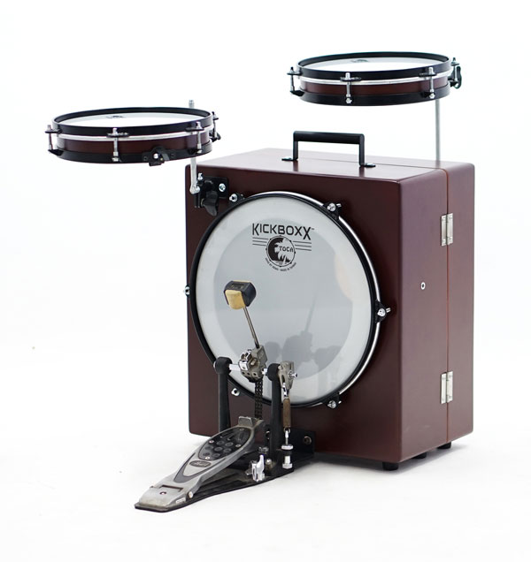The Kickboxx™ Suitcase Drumset, launched at NAMM 2020 by Toca Percussion, sets a new standard in drum kit portability and convenience. Standing a mere 22 inches tall, the entire set-up fits inside the box with room left for a kick pedal. The Kickboxx itself features a 14” Remo P3 head, plate for attaching a standard bass drum pedal and is ported in the back. There are adjustable mounting posts installed front and back for attaching the tom, snare and other accessories. The posts telescope in and out from the box and can be rotated up for playing or down for storage. Secured with 2 sturdy latches, the hinged box swings open to allow the snare and tom to be secured to the post on the inside of the box. A fixed handle doubles as a rack tube for attaching additional drums and accessories.

The 10” tom and snare are based on Toca’s popular frame drums and feature two thick plys of Asian Oak topped with coated Remo heads. The snare drum features an adjustable, fan-style snare complete with throw-off.

“It’s tough to get a good sound from small drums like this—especially snares,” noted Lane Davy, RBI EVP of Sales and Marketing. “The biggest problem is getting enough even tension on the head. We fixed it by using a robust bongo-style counter hoop and bottom ring.”

According to Davy, the main goal was to produce a truly functional musical instrument in an ultracompact form. “The Kickboxx is a musical instrument first. We started by designing drums that sounded good and then built the concept from there,” he notes. “What we didn’t want was a gimmick with no substance.” Perfect for tight performance areas, busking, tiny homes or drummers with small cars, the Kickboxx takes drumset portability and convenience to a whole new level.

[tocapercussion.com](http://www.tocapercussion.com)