**Contact:** Jim Rockwell **FOR IMMEDIATE RELEASE**

RBI Music

**Tel:** 201-247-7224

**Email:** [marketing@rbimusic.com](mailto:marketing@rbimusic.com)

**Toca Adds Popular Woodstock Purple model to Beloved FreestyleLightweight Djembes!**

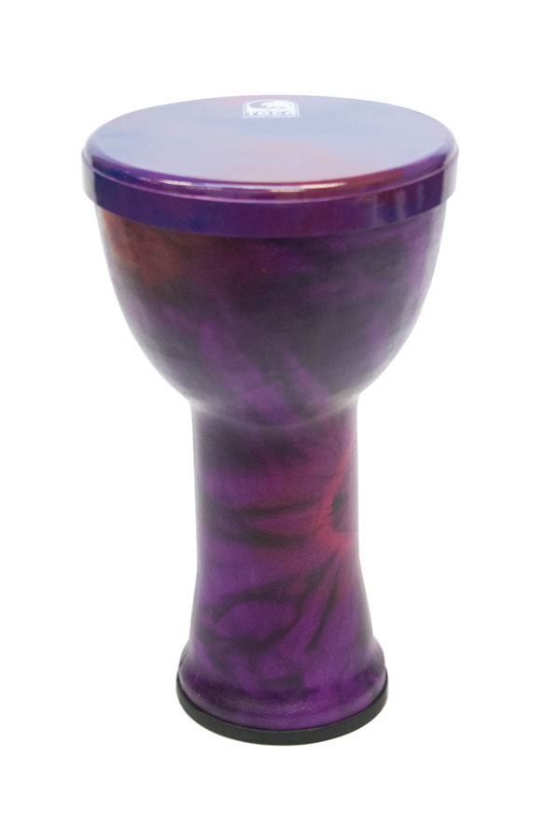These djembes may be called “Lightweight” but don’t let the name fool you. That only refers to the actual weight the drums. When it comes to sonic performance, powerful projection, and genuine value, these drums are definitely in the heavyweight category. Since their successful introduction the Lightweight Djembes featured a patented hybrid design that combines elements of a doumbek with those of a djembe. The sculpted shell is made of an ultra-light synthetic material that dramatically reduces the weight of the drum without sacrificing tone, resonance, or durability. A rubber edge protects the bottom of the shell. Available in 9”, 10” and 12” sizes, each Lightweight Djembe is topped with a permanently attached pre-stretched synthetic head.

In combination with the ultra-light shell, this durable head helps each Lightweight djembe to produce clean open tones, crisp slaps, and rich, deep bass tones. The unprecedented portability and sound quality of these djembes make them excellent choices for drum facilitators and music teachers. Professional hand drummers will appreciate their potential as soloing instruments, and players of all levels will appreciate the updated hand-painted finishes. In addition to the Jamaican-inspired Rasta and the African-themed Earth Tone now Toca offers up a third color, Woodstock Purple. Followers of the Toca brand will recognize this popular color from other drum models across the line such as their Rope Tuned Freestyle Djembes and Freestyle II Nesting Djembes and Tom-Toms. This joyous pattern combines purple, red and shades of blue into a cool tie-dye effect reminicent of the Woodstock Music Festival aesthetic. The fact that the finish covers both the shell and the head adds to the visual uniqueness of these innovative drums.

[tocapercussion.com](http://www.tocapercussion.com)