**Contact:** Jim Rockwell **FOR IMMEDIATE RELEASE**

RBI Music

**Tel:** 201-247-7224

**Email:** mHYPERLINK <mailto:marketing@rhythmband.com>

**ood Congas and Bongos – Now In Stunning Sahara Gold**

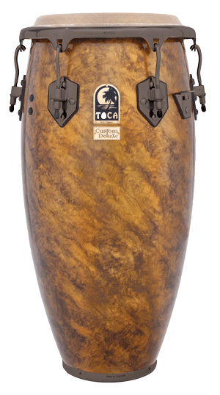The creative team at Toca Percussion has expanded the color range of their popular Custom Deluxe Wood conga series to now include a stunning Sahara Gold finish for 2019.

Bathed in a clear coat and hand polished to a glisten, the interplay of the various shades of gold and the sophisticated black nickel hardware erupts under the stage lights and grabs the audience’s attention like a beacon. That mesmerizing affect will prove difficult to ignore!

Percussionists have long appreciated the added volume and resonance born from the contemporary Afro-Cuban profile of Custom Deluxe Wood drums. Available in a 12.5" tumba, 11.75" conga, 11" quinto, and matching 7" and 8.5" bongos, these Asian oak shells are outfitted with such pro features as high-luster chrome hardware, matched top-grade natural bison heads, and EasyPlay hoops — an ergonomic solution that never compromises traditional tone or resonance.

“At Toca, we not only understand the importance of sounding good” says Lane Davy, Executive Vice President of Sales and Marketing at RBI, “but also appreciate the need to look good on stage. This new finish will do just that for any percussionist looking to add some fire to their setup.

The new Sahara Gold color option will debut in booth 7212 at the 2020 Winter NAMM Show, and joins the existing Natural gloss, transparent Blue, and Black Sparkle finishes for Custom Deluxe Wood congas and bongos.

rbimusic.com