**Contact:** Jim Rockwell **FOR IMMEDIATE RELEASE**

**RBI Music**

**Tel:** 201-247-7224

**Email:** marketing@rbimusic.com

**Grover Pro Continues to Innovate - Introduces 3 New Products**

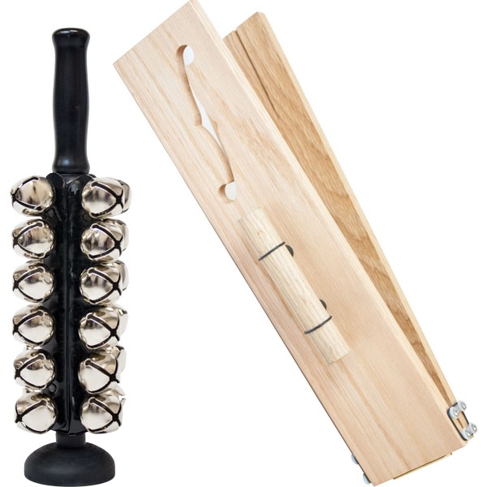RBI Music is thrilled to announce the introduction of three exciting new additions to their Grover Pro Percussion line of high-quality products. Grover Pro’s instruments are renown by percussionists around the globe and are found in the world’s finest concert halls.

The new Grover Pro Sleigh Bells have twenty-four resonant steel bells that are permanently attached to a turned hardwood handle. Exquisitely finished in concert black, a particular highlight is the hard rubber “foot” that allows the player to quickly and silently pickup or set down the instrument, eliminating any unwanted bell sound. These are the only commercially available sleigh bells with this feature. The foot also functions as an easy grasp handle to facilitate ease of playing loud passages.

Grover Pro’s new solid Red Oak Slapstick measures a full 16” by 3.5” and comes with two tension bands that are fully adjustable. Incorporated into the design is a decorative “f-hole” and internal grooves, both of which function to maximize attack. A unique component of the new slapstick is the ability to mount it on a standard threaded cymbal stand (or threaded post), allowing the instrument to be played with one hand, when necessary.

Unlike anything else on the market today, Grover Pro’s innovative 360° Multi Instrument Mount provides virtually unlimited flexibility to players needing to mount small instruments in a compact space. Examples of the type of instruments that can be mounted are Grover Pro triangles, tambourines, woodblocks, castanets and the new slapstick. In addition, countless products from other percussion manufacturers can be easily mounted on the 360° MIM. Every unit includes a heavy-duty soft case which holds the mount and all of its accessories.

“I am sure that almost everyone in the industry has heard about my products joining RBI Music’s stable of quality musical products,” said Grover Pro founder, Neil Grover, “and that affords me significantly more time for developing new products. I am confident that our first three collaborations are all clear winners!”

Lane Davy, EVP-Sales & Marketing at RBI Music agreed, “Neil is a treasure trove of fabulous ideas. We’re very lucky to be working with a practicing professional like him on new products like these.”

Rhythm Band Instruments has been distributing musical instruments and music education material from Fort Worth, Texas for nearly 60 years. The company acquired the assets of Grover Pro Percussion in 2019.

rbimusic.com

groverpro.com