Contact: Jim Rockwell FOR IMMEDIATE RELEASE
RBimusic
Tel: 201-247-7224
Email: marketing@rbimusic.com

A Tempo Expands Snare & Tocador Series with With Three Special Edition Cajons!

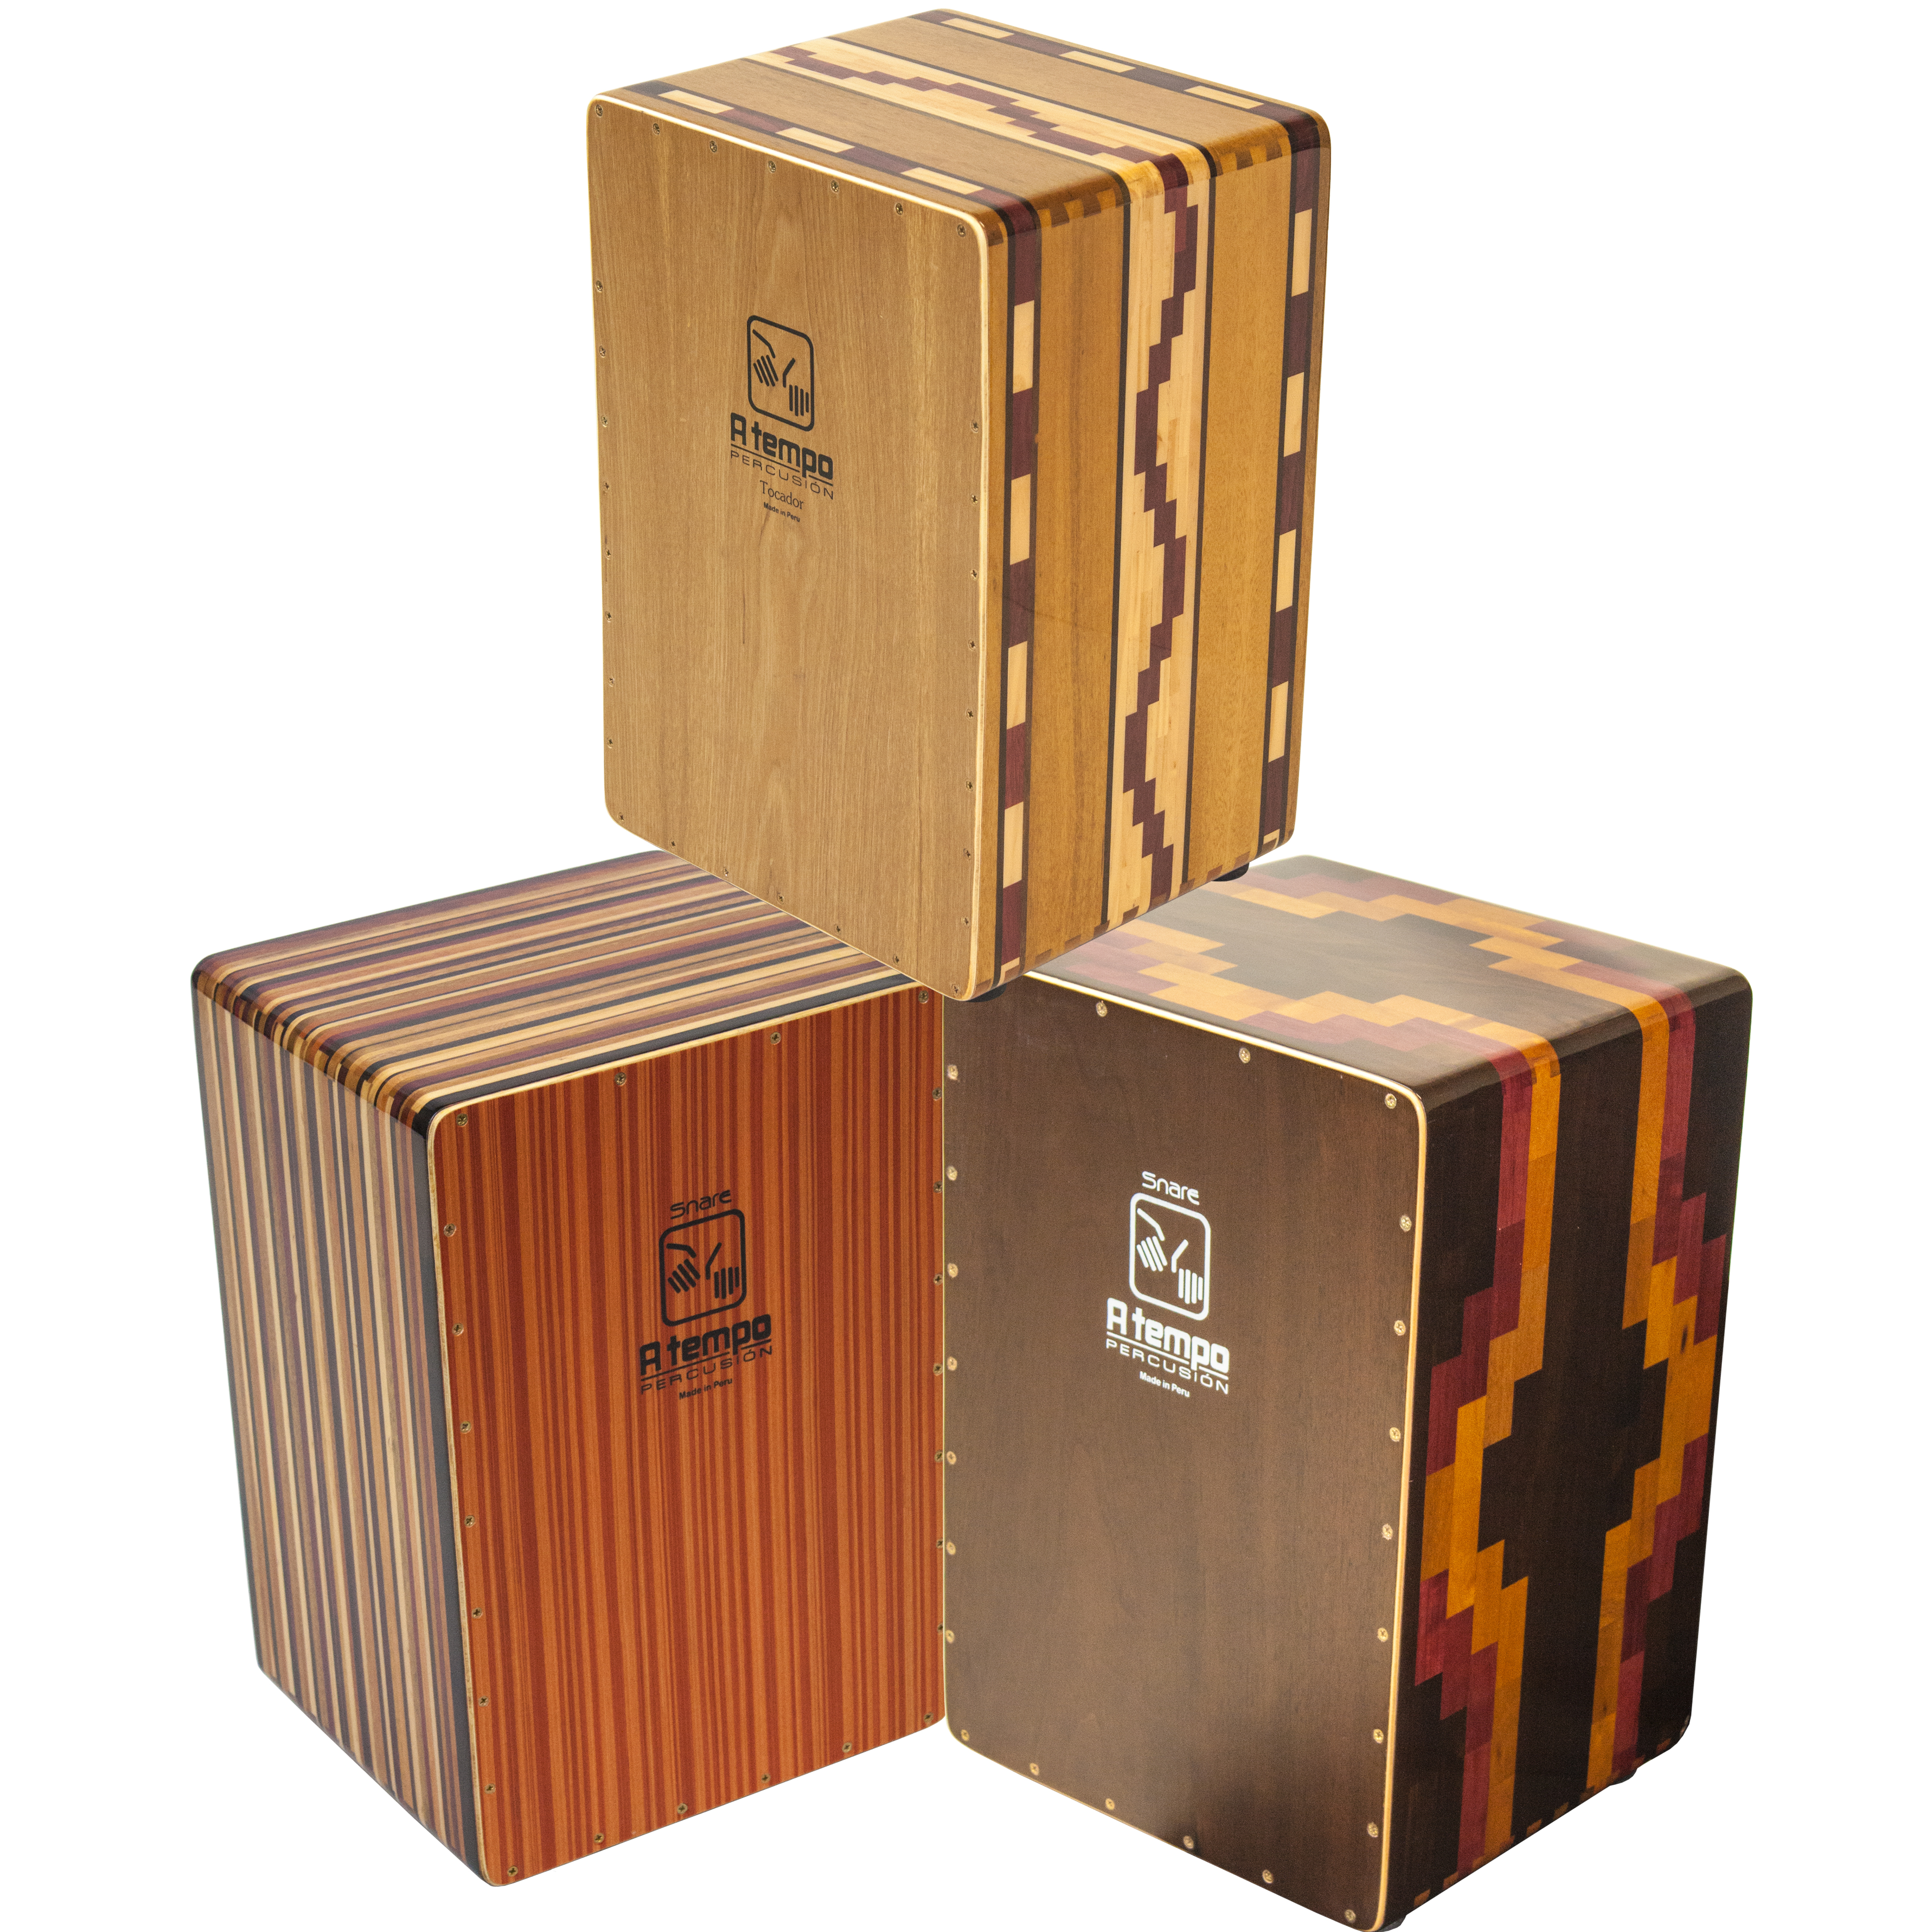
A Tempo is known not only for its high quality craftsmanship, it is also known for the stunning beauty of the drums it produces. It is with that aesthetic background in mind that they introduce three new models that will do nothing to tarnish this long-standing reputation.

First up are two new Snare Cajons. These drums produce a Traditional Peruvian sound with deep, defined bass and are made from solid wood body Construction – dried to a precise 8 percent moisture level. The CJ-SNARE-SE1 comes with a multi-ply Walnut playing surface and a resonant side made from Pupleheart that features a segmented and joined “diamond” pattern. The CJ-SNARE-SE2 is replete with a stunning Rainbow Stripe that can be found on all sides of the drum. Both cajons are finished with dovetail joints and furniture-grade gloss. They are fitted with Flamenco style snare wires and a bright body finish in Polyester and Polyurethane with Matte front. Includes A Free padded gig bag is also included.

A Tempo Percussion’s Tocador Flamenco Cajon is made in Peru, just like all A Tempo products, considered to be the birthplace of the cajon as an instrument. The body panels of this cajon are made from select pieces of solid Mohena and Purpleheart that are fashioned by hand into a truly eye-catching pattern and then joined using the sturdy dovetail technique. The front features a multi-ply Spanish Cedar and Lupuna tapa (playing surface). All Tocador Cajons feature snare wires placed in the traditional flamenco “W” configuration. The result is the deep, solid bass of a Peruvian cajon and the snap and sizzle of a Flamenco cajon. The cajon is finished in an attractive, furniture-grade satin finish. A Free padded gig bag is also included.

CJ-SNARE-SE1
CJ-SNARE-SE2
CJ-TVIOL-01

atempopercusio.com
rbimusic.com

