**Contact:** Jim Rockwell **FOR IMMEDIATE RELEASE**

RBI Music

**Tel:** 201-247-7224

**Email:** [marketing@rbimusic.com](mailto:marketing@rbimusic.com)

**Casey Grillo and Jules Radino Sign with Toca Percussion!**

**(Subtitle – Toca has more drummers from Ümlaut bands than you!)**

Toca Percussion is pleased to announce the signing of two drummers playing in two of the most iconic bands in rock history.

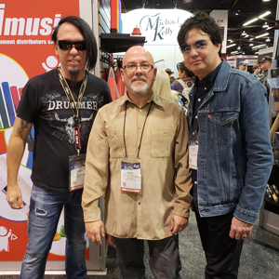Casey Grillo is the drummer for *Queensrÿche*, who bestowed upon the world the Grammy nominated hit “Silent Lucidity”. He got his professional start at the age of 16 and spent more than 20 years in the band *Kamelot* Before joining *Queensrÿche* in 2017. Casey is well known for his astounding double bass skills, and his hands and overall technique reveal a studied and musical past. He utilizes a number of Toca drum set add-ons in his set up and is “very excited to be endorsing Toca Percussion’s innovative products. It makes my sound both in the studio and live on stage complete!”

Jules Radino is the drummer for rock and roll legends Blue Öyster Cult, known for such massive hits as “Don’t Fear The Reaper”, “Godzilla” and the impetus of “More Cowbell”. Before joining BÖC in 2004 Jules toured with Poppa Chubby and when not on the road he keeps an active schedule recording, performing and teaching drums in the NYC area. Upon his signing to Toca he exclaimed “I’ve been playing Toca Percussion for over 20 years! I’m humbled to be a member of the Toca family and to be included on the roster with all these amazing drummers!”

L to R: Casey Grillo; Mark Petrocelli; Jules Radino

“Having two artists with the breadth of talent and styles that Casey and Jules possess joining the Toca roster speaks volumes about the influence of this brand,” says Artist Relations Manager, Mark Petrocelli. “We are committed to expanding Toca’s reach around the world with instruments and artists!”

[tocapercussion.com](http://www.tocapercussion.com)