Contact: Jim Rockwell FOR IMMEDIATE RELEASE
RBI Music
Tel: 201-247-7224
Email: jim@filamentsolutions.com

Toca Erik Piza Signature Bongos Make a Bold Statement

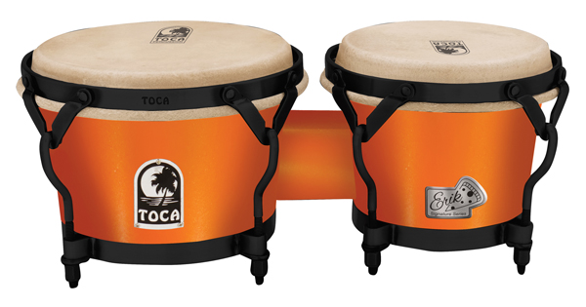
Veteran percussionist Erik Piza can barely contain his enthusiasm while describing the fresh ideas built into his new Toca Signature Bongos — like the way the set features 7" and 9" drums instead of the traditional 7" and 8.5" sizes without adding extra overall weight, thanks to a proprietary technique that reduces mass.

“In all my years of playing, I’ve never seen a 9" fiberglass hembra with a traditional rim,” he says. “The bigger drum size gives me a more powerful lower pitch that really projects.”

He’s also jazzed about his Signature model’s durable black powder-coated hardware (for a little drama), EasyPlay hoop (for extra hand comfort), Remo tucked Fiberskyn® heads (for authentic tone), contoured shells (for secure leg grip-ability), and its smaller center block that pulls the two drums closer together (for quick movement from one drum to the other).

Above all else, he seems most excited about the set’s unusual Orange Flame finish, prompting us to ask: What’s that about? “My name is Piza. I also happen to be a big fan of pizza,” he laughs. “So I thought it would be a great way to relate the color with my name — and also tomato sauce!”

The 11-year Toca endorser can’t wait to put his new Signature Bongos through the paces during his upcoming work with jazz star and former Yankees centerfielder, guitarist Bernie Williams, as well as on dates with 14-time Grammy Award winner, pianist Eddie Palmieri. “I played on Eddie’s new album, which comes out in 2019,” Piza says. “Between juggling my work with him and Bernie, I’m gearing up for a heavy touring schedule throughout the year.”

Toca Erik Piza Signature Bongos will debut in booth 6404 at the 2019 Winter NAMM Show.

