**Contact:** Jim Rockwell **FOR IMMEDIATE RELEASE**

RBI Music

**Tel:** 201-247-7224

**Email:** jim@filamentsolutions.com

**New Black Sparkle Finish for Toca’s Custom Deluxe Wood Congas**

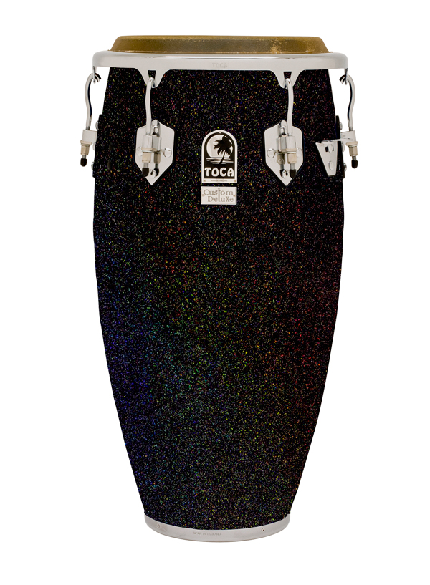The creative team at Toca Percussion has expanded the color range of their popular Custom Deluxe Wood conga series to now include a breathtaking Black Sparkle finish for 2019.

Bathed in a clear coat and hand polished to a glisten, the generous array of silver sparkles floating in an opulent black background explodes under stage lights like a multicolored constellation in the night sky, creating a three-dimensional illusion that looks as if you could almost reach directly into the shell.

Percussionists have long appreciated the added volume and resonance born from the contemporary Afro-Cuban profile of Custom Deluxe Wood drums. Available in a 12.5" tumba, 11.75" conga, 11" quinto, and matching 7" and 8.5" bongos, these Asian oak shells are outfitted with such pro features as high-luster chrome hardware, matched top-grade natural bison heads, and EasyPlay hoops — an ergonomic solution that never compromises traditional tone or resonance.

“We’re all players first at Toca,” says Lane Davy, Executive Vice President of Sales and Marketing at RBI. “So we not only understand the importance of sounding good, but also appreciate the need to look good on stage. This new finish is the perfect answer for any percussionist who wants to add some flash to his or her setup.”

The new Black Sparkle color option will debut in booth 6404 at the 2019 Winter NAMM Show, and joins the existing Natural gloss and transparent Blue finishes for Custom Deluxe Wood congas and bongos.

rbimusic.com